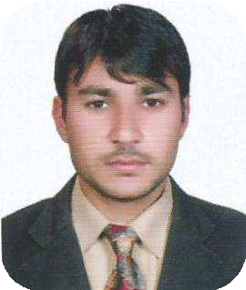IRFAN ULLAH

**Postal Address: Hor Alanz Deira Dubai**

**Email:**

**Cell:**

[irfanktk937@gmail.com](mailto:irfanktk937@gmail.com)

00971-551455327



**OBJECTIVE:**

* To work in a progressive organization that has strong business values and healthy workenvironment, to utilize my abilities in the best interest of my employer and my personalgrowth.



**KEY** **SKILLS:**

* + **Microsoft Office (Word, Excel, and PowerPoint).**
  + **Excellent customer service and Filing System**
  + **Excellent communication skills.**
  + **Accounting Record Keeping**



**PERSONAL** **INFORMATION:**

* **Full** **Name** **:** **Irfan** **Ullah**
* **Father** **Name** **:** **Fazal** **Badshah**
* **Date** **of** **Birth** **:** **19-05-1993**
* **Passport** **no** **:** **LK2746962**
* **N.I.C.** **:** **14203-7766696-1**
* **Domicile** **:** **Karak** **(KP)**
* **Nationality** **:** **Pakistani**



**ACADEMIC** **QUALIFICATION:**

|  |  |  |  |
| --- | --- | --- | --- |
| **Degree** | **Session** | **Discipline** | **University/ Board** |
| **BBA** | 2016 | Finance | Agriculture University Of Peshawar |
| **D. Com** | 2011 | Accounting | BTE Peshawar |
| **SSC** | 2009 | Science | BISE Kohat |



**EXPERIENCE:**

* + 2 years of experience Data Entry in mobile shop
  + 2years of experience in single entry of Accounting. General Entry, Ledger ,Trail Balance, Balance Sheet, Incom Statement, Daily reports
  + 03 Weeks Internship in PTCL.
  + 06 Months Course of MS Office.

**COMPUTER** **SKILLS:**

* MS Office. (Word, Excel & PowerPoint)

**DRIVING** **LICENCE:**



* United Arab Emirates Light Vehicle
* Pakistan Motorcycle , Motorcar , Jeep

**LANGUAGES:**

* English, Urdu and Pashto.