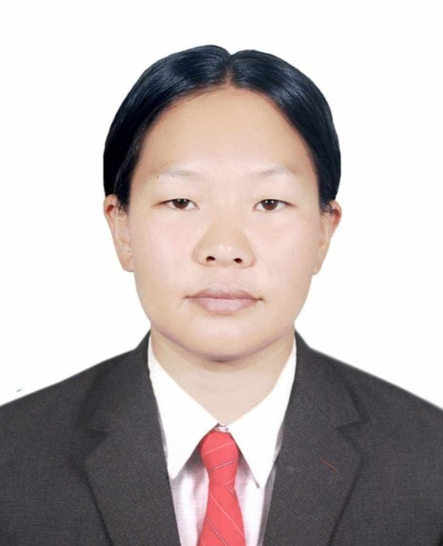

# HOTEL UGRACHANDI & Restaurant|2020-2022|

# Cook

Task

* + - * Maintain a clean and organized kitchen.
      * Wash and chop vegetables and meat.
      * Responsible for the preparation of high-quality food.
      * Providing support to the head cook in the preparation and service of meal.
      * Follow the prep list created to plan duties.

# Hotel Annapurna Durbar Marga, Nepal|2017-2020|

# Waitress|2018-2019|

* + - * Greet customers as they settle at the tables in the restaurant.
      * Inform costumers of the daily and weekly specials.
      * Records customer orders and submit them to kitchen staff.
      * Serve food to customers and refill their drinks.

# Housekeeping (Public area & guest room attendant) |2017-2018|

Ability to work in a team

Ability to Multi task

Deep sanitation Practices and effective time management.

**WORK EXPERIENCE**

**DIPLOMAS Y HOBBIES**

**Formaciones :** Diplomados, Congresos, xxxxxxxxxx xxxxxx xxxxxxxxx xxxxxxxxxxxxxxxxx

**Hobbies:** xxxxxxxxxxxxxxxxxxxxxxxxxxxxxx

**MINGMA SHERPA**

Customers service

**SUMMARY**

A highly motivated and adaptable professional with a strong passion for continuous learning and personal growth. Possessing a diverse set of skills and knowledge, I am driven to excel in a dynamic and progressive work environment. Through effective communication and collaboration, I aim to contribute to the success of the organization and work alongside a diverse team to achieve common objectives. With a keen eye for detail and a proactive approach, I am committed to delivering results and making a positive impact in this field.



MAE ANGELI YEE-CARINO  
Placement Manager at Vibe Education

+971 509680018  
placement@vibe-edu.com

**REFERENCES**

English

Hindi

Nepali

**LANGUAGES**

# 2023-Pursing | Dubai-UAE

Bachelor in Tourism and Hospitality Management at Vibe educational institute

# Passed out in 2022 | Banepa, Nepal

Diploma in Hotel Management from Nepal Banepa polytechnic institute (NBPI)

# Passed out in 2012 | Banepa, Nepal

SLC from Lin international secondary boarding school

**EDUCATION**

* Decision making
* Strong communication
* Team work
* Multitasking
* Adaptability

+971 505892234

Mingmajangmu747@gmail.com

Dubai , UAE

Visa- Student / resident

©AZURIUS - My-resume-templates.com

**SKILLS**

**CONTACT**