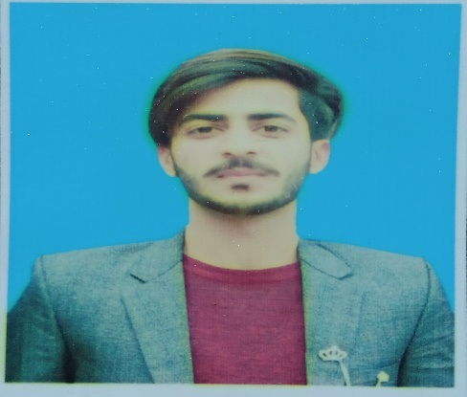 |  | Muhammad Haris  PERSONAL INFORMATION  Father Name : Muhammad Ramzan  Marital Status : Single  Nationality : Pakistani  Religion : Muslim  D.O.B : 11/03/2000  CNIC # : 33203-4319993-5
Profile  I am Muhammad Haris. Seeking to work in dynamic environment at challenging position of greater responsibilities to expand my skills. Skill set contribution of organization as well as my own professional persuit. All of things that i have learnt from self-learning techniques neither from any institution nor any resources.  Contact  PHONE:  +971 056 207 5281  EMAIL:  mharis12430@gmail.com  Address:  Baniyas center naif road daira dubai  LANGUGES:  - English  - Urdu  - Punjabi |  | EDUCATION  Islamabad Model School for Boys F7/3, Islamabad.  2018 - 2020  I complete my FSC (ICS) in 2020 from imcb f7/3 affiliated with federal board.  Jinnah Muslim School and College.  2016 - 2018  I complete my Matric (science) in 2018 from jinnh mislim school nd college affiliated with federal board.  DIPLOMA  - 3 months certification in Basic IT.  - 3 months certification in Solar photovoltaic.  - 3 months certification in Electrician.  WORK EXPERIENCE  - 1 year working experience with Save Mart as a Cashier or Sales Executive.  - 1 year Marketing experience in Real Estate.  - 6 months Internship with Transworld TM as a full time IT Internee or a SAP internee also complete Assets tagging project related with admin.  - 1year working with Seedcred Financial Services Pvt. as a Recovery Agent.  - 1year working with Incresco Digital Solutions as a Recovery Agent.  SKILLS  - Ms-office ( Ms word, Ms excel, Ms PowerPoint, )  - Good command over computer hardware and software.  - Excellent internet emailing, browsing, surfing applications.  - Good command over window installation, driver’s installation and other applications.

