Curriculam Vitae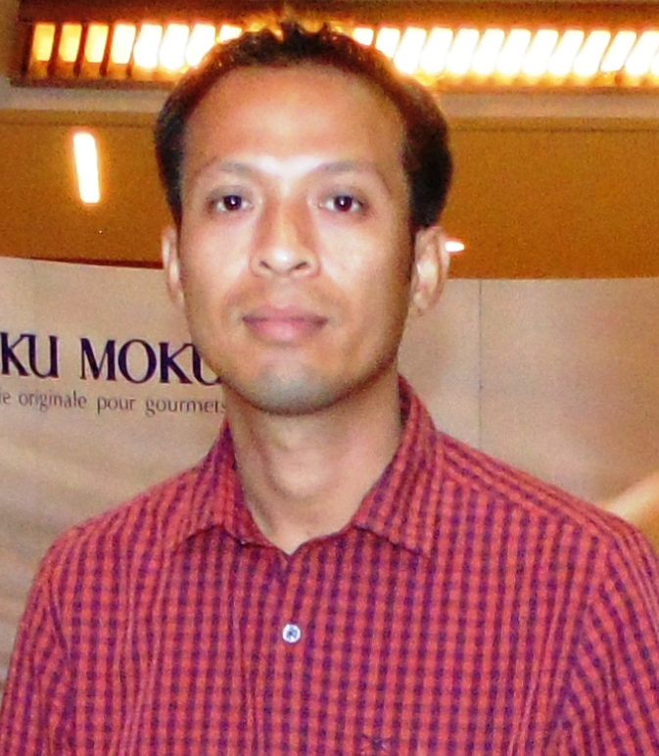

Email:- raghu.moiran@gmail.com Mble :- +917086434756

Age – 37, Sex - Male +918134994650

Name :- M. RAGHUMANI SINGHA

Education : - 10+2

Technical Education :- i) Diploma Electrical Engineering (DEE).
ii) I.T.I . Electrician NCVT
iii) Basic Computer course from I.I.C.S. 6 months

Technical License :- Supervisor’s License Certificate 7 steps. 2014 July from Assam Electrical Licensing Board .

Years of Experience :- 16 yrs Exp.

Experience As:- Working at ALPET CONTAINERS UNIT - III as an Executive Maintanance since 10th July 2020 to till Date.

Working at VLCC Ltd. Personal Care as an Supervisor Maintanance since 25th January 2018 to july 2020.

worked at Orient electric Ltd. Breaker, lighting,Fan manufacturing as an supervisor since 14 th March 17th to January 16 2018.

Worked at Technical Nano Eletromechanical L.L.C. UAE as an Electrician from 7 th August 2014 to 25 th October 16

Worked at M/S Dalmia Bharat Cement Ltd. at as an
Sr. Elecrician from 07th February 2007 to 08th July 2014

Jobs Handled :- All Machine n Equipment CLIT,Prevantive Maintenance, Yearly Maintenance and High Pressure compressure , LP and DG Service Maintenance.

Transformer installation and maintenance.
DOL, RDOL, Star Delta Starter Rectified and maintanance.
Single Phase and Three phase Motor installation & Testing.

LPB or LCS control Rectification.

MDB, SMDB & DB Dressing.

Cable glanding and Lugging HT & LT.

MCB,MCCB,RCB (Breaker) installation.

DG Operation and maintenance

ETP Monitoring and operation.

Chiller Monitoring and operation .

Fire hydrant automation Pump Maintain.

Prevantive Maintanance.
CLIT Maintain

Address n communication :- S/O. L M. CHANDRA HAS SINGHA
Address :- Rongpur – 1, P.O. – Rongpur – 2,Silchar
Dist: - Cachar, State – Assam, Silchar :- 788009

Present Address :- Alpet Containers Unit-III,
Chhaygoan AIGC,
Satabari, Assam

Language Known :- Hindi, English, Bengali, Assamese, Manipuri.

Date:- Your’s Faihtfully

Mr.M.Raghumani Singha

