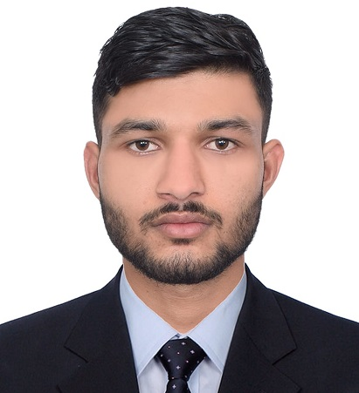
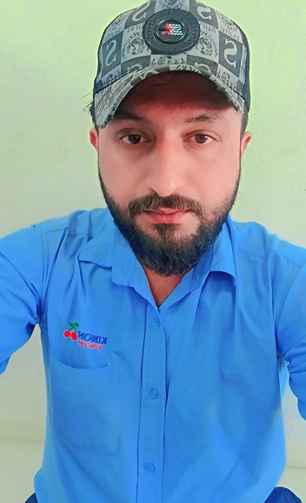
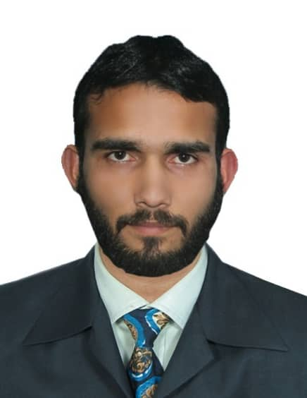
CURRICULUM VITAE

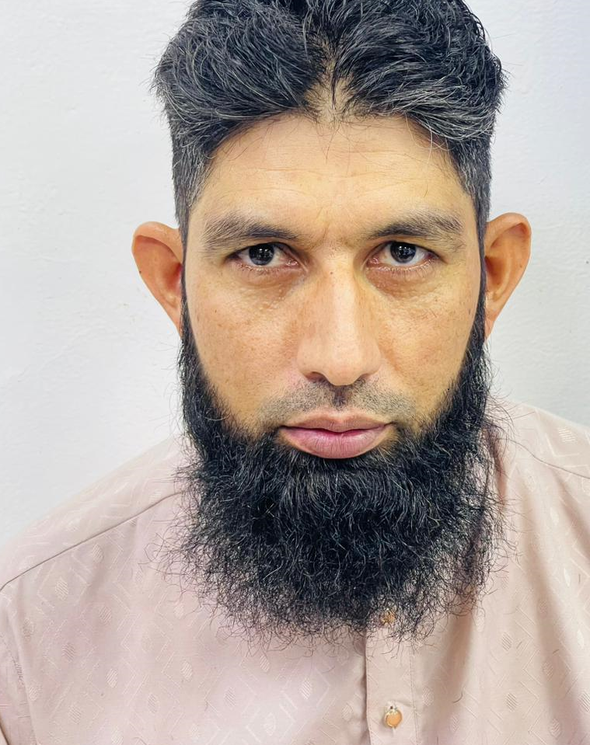
NAME: AFAQ KHAN
EMAIL: afaqk7530@gmail.com
PERMANENT ADRESS: ABU DHABI UAE

PHONE NO: 050-2296315

POST APPLIED FOR THE POSITION “OPERATOR”

PERSONAL DETAILS
Name : AAFAQ KHAN
Date of Birth : 15-05-2000
Nationality : Pakistan
Marital Status : Single
Religion : Muslim
Gender : Male
Visa status : EMPLOYMENT Visa
CAREER OBJECTIVE:
To be part of your esteemed organization enabling me to achieve the company goal which are of paramount importance and wherein driving personal satisfaction by gaining optimum, expertise and function knowledge.
EDUCATION
- S.S.C, F.A.C, B.S & D.I.T
LANGUAGE KNOWN
English, Urdu
PASSPORT INFORMATION:
Passport NO : KG4156811
Issue Date : 15-09-2022
Expiry Date : 14-09-2024
PROFESSIONAL EXPERIENCE:
- RUN business as a “WEIGHT SCALE OPERATOR IN PAKISTAN..
- Presently working as a Forestry Worker with Barari Natural Resources 06 months to till now.
SKILLS:
- Very Energetic result oriented and organization
- Efficient and Well behaved person
- Extremely hardworking self-motivated person
- Keep excellent inter personal relation with colleagues and ready to help them
DECLARATION:
I hereby declare that the above-mentioned details are complete and true to the best of my knowledge and belief

