AFSAL.S

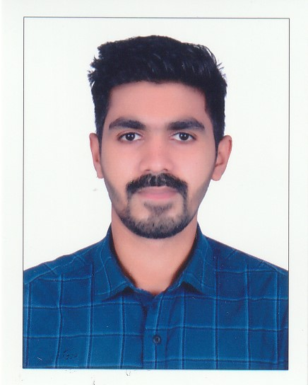

AFSAL.S

Afsalacl786@gmail.com

Ph no: +971 507036034

**PERSONAL DETAILS**

**Nationality : Indian**

**Date of Birth: 31/05/1995**

**Sex : Male**

**Marital Status : Single**

**Blood Group : A+ve**

**Uae driving license:4360858**

**LANGUAGES KNOWN**

English

Hindi

Malayalam

Urdu

**PERSONAL STRENGTHS**

* Excellent managerial and communication skill
* Can work under high pressure environment with efficiency
* Hazard and risk analysis
* Decision making
* Self-motivation

**HOBBIES**

* Cricket
* Football
* Travelling

## PROFILE

To secure a challenging position in a reputable organization to expand my

learnings, knowledge, and skills. To secure employment with a reputable

company, where I can utilize my skills and business studies background to

the maximum.

# EDUCATION

* **PLUS TWO**
* **SSLC**

## WORK EXPERIENCE

**1.MERCHANDISER (Oct 2016- Nov 2018)**

## HMB LLC, Dubai

## 2.I have been working as a MERCHANDISER in JALEEL DISTRIBUTION from 6th Feb 2022.

## 

## PASSPORT DETAILS

**Address**

Snaz Manzil,

Swami Mukku Pilippara P O Kollam (Dist) Kadakkal, Kerala, India

Pin : 691536

## Passport No : N 2576574

## Date of Issue : 09/09/2015

## Date of Expiry : 08/09/2025

## Place of Issue : Trivandrum

# SKILL

1. [Strong communication skills](https://www.talentlms.com/blog/essential-skills-training-tools-for-trainers/#2_Strong_communication_skills)
2. **Organizational skills**
3. **Hardworking**

# DECLARATION

## I confirm that the above-mentioned particulars are true and accurate to the best of my knowledge and that I have not meant any intentional mistakes

Place: ANCHAL AFSAL.S