2

P

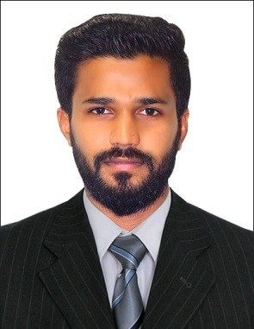**CURRICULUM VITAE**

# AFSAL T

**Email :** [**afsalyemkay35@gmail.com**](mailto:afsalyemkay35@gmail.com)

# Passport : P1367235

**Visa Status : Employment visa (***Transferable*)

# Mobile : +971562842283

**CAREER OBJECTIVE:**

I am an energetic person with great passion in the career, want to be a part of a renowned organization, to contribute towards the growth, based on my expertise and to further my knowledge and advance my personal capabilities from the new exposure within the structured framework of the organization.

# STRENGTHS

* Ambitious and highly motivated to meet the demands of the job
* Excellent skills in marketing and business development
* Experienced in merchandising and managing sales in various retail outlets and international brands
* Have a track record of getting results and generating sales and improve the service offered
* Able to identify and develop new business opportunities
* Exceptional communication skills
* Good time management skills

# KEY SKILLS

|  |  |  |
| --- | --- | --- |
| Visual Merchandising | Problem Solving | Time Management |
| Product Placement | Sales Analysis | Market Research |
| Communication Skills | Customer Services | Team Leadership |

**LINGUISTIC ABILITY**

* English
* Hindi
* Malayalam
* Tamil

# EDUCATIONAL QUALIFICATION

* + BBA from Bharathiyar university 2016

2

P

* + Higher secondary central board 2013
  + S.S.L.C Kerala state board 2011
  + Certified professional E-FILLING (TALLY ERP 9)
  + Certified professional in MS OFFICE

# PROFESSIONAL EXPERIENCE

**Company name :** Kohaj Supermarket Dubai UAE

**Job Role :** Merchandiser & Salesman

**Period :** 2019th Oct -- still working

**DRIVING LICENSE**

# DRIVING LICENSE

**Having UAE Valid manual driving license ( Issue Date: 01/04/2019)**

# RESPONSIBILITIES

* Proven experience as an merchandiser or salesman.
* Knowledge of office management systems and procedures.
* Proficiency in MS Office (MS Excel and MS PowerPoint in particular)
* Excellent written and verbal communication skills.
* Attention to detail and problem solving skills.
* Excellent time management skills and the ability to prioritize work.
* Strong organizational skills with the ability to multitask.

# PERSONAL PROFILE:

**Nationality :** Indian

**Gender :** Male

**Date of Birth :** 11thAug 1995

**Marital status :** Single

**Languages Known :** English, Hindi,and Malayalam &Tamil.

**Passport No :** P1367235

**Visa Status :** Employment visa (*Transferable)*

# DECLARATION:

I hereby declare that the information furnished above is true and correct to my knowledge and belief.

# AFSAL T