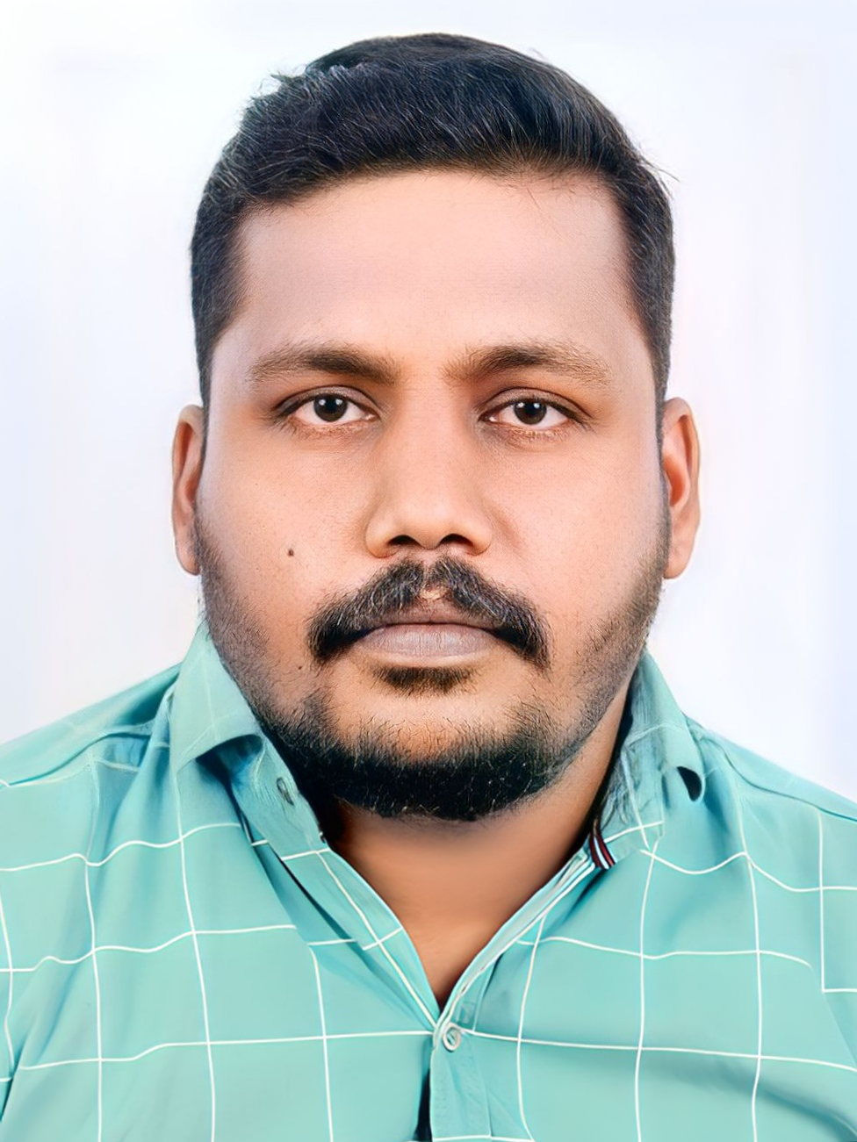 |  | AJITH RAJAPPAN  SUPERVISOR
ersonal information  Date of Birth : 13/02/1992  Gender : Male  Marital Status : Unmarried  Father’s Name : Rajappan P.K.  Nationality : Indian  Address : Puthuparambil House  R.P.C. P.O.  Vandanpathal,  Mundakayam  Kottayam,  Kerala – 686513  Passport No. : P5855161  Contact  Mob.: 91-9947853442  Emai: ajithrajappan007@gmail.com  LANGUAGES KNOWN  Hindi, English, Thamil, Malayalam  HOBBIES  Sports & Music |  | EDUCATION  B.A. Economics from M.G. University for the period of 2012-2015  WORK EXPERIENCE  Presently Working with M/s. ROCKFIELD ESTATE Pvt.Ltd. as Supervisor from 2019.  Worked with ALL BULBUL GLASS & STEEL COMPANY, UAE as Aluminum Fitter from 2017 to 2019.  Worked with MUTHOOT HONDA, Thodupuzha from 2015-17.  SKILLS  - Managing the work climate  - Leadership  - Essential Management skills of a Construction Frontline Supervisor  - Effective Communication Skills of a Construction Frontline Supervisor  - Planning  - Directing  - Delegation  - Expending and follow up  - Certified First Aider  LICENSE  - FORKLIFT OPERATOR  - EXAVATOR OPERATOR  - HEAVY DRIVER  - TRAILER DRIVER

