ANURAG C D

# PROFILE

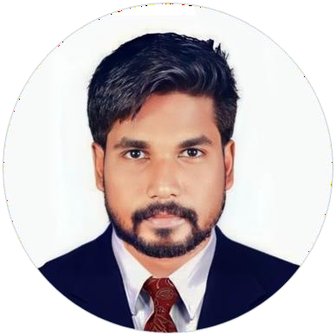

## CONTACT

+91 9074439907

[anuragcd1994@gmail.com](mailto:anuragcd1994@gmail.com)

Vipin Nivas Manampoor, Varkala

Thiruvananthapuram District

Kerala-695611, India

## PERSONAL DETAILS

Date of Birth : 17-05-1994 Gender : Male Marital status : Single Nationality : Indian Passport No : R1988733 Expiry Date : 27/06/2027

## TECHNICAL KNOWLEDGE

* CCTV Technician
* Computer Knowledge

## LANGUAGES

* English
* Malayalam
* Tamil

## PERSONAL SKILLS

* Willingness to learn & work

hard

* Multi-tasking
* Leadership quality
* Good listener
* Cash Handling
* Keep Customer Relationship
* Problem solving

To achieve an opportunity in such a reputed organization where I can enhance and utilize my challenging and hardworking capabilities to full extent and that can provide me a gate for learning and career development.

# EDUCATION

### BACHELOR OF SCIENCE IN ZOOLOGY (B.Sc Zoology)

Kerala University | 2015

### HIGHER SECONDARY EDUCATION

Kerala Higher Secondary Examination Board | 2012

### SECONDARY SCHOOL LEAVING CERTIFICATE

Board of Public Examinations Kerala | 2010

# WORK EXPERIENCE

**RELATIONSHIP OFFICER** 2020 to 2023

**ESAF Bank,** Trivandrum, Kerala

* + Develop and maintain professional understanding of customer base to assist Banker deepening current relationships.
  + Perform as key contact for selected customer relationships under Banker guidance.
  + Ensure to alert Banker with respect to any delays along with potential issues.
  + Provide assistance to Banker to attain approval on new account openings.
  + Ensure to alert Banker of prospective sales opportunities surface from discussions with clients.
  + Collect mandatory information to analyze client situation.
  + Perform as key contact point for portfolio of clients dealing with routine matters throughout range of services and products.

**Salary Sales Manager (Deputy Manager)**

**ICICI Bank, Kollam Cluster** 2023 to Till Date

### SALES EXECUTIVE

**Vinayaka Automobiles,** Trivandrum, Kerala

### ECONOMIC SURVEYOR

**CSC,** Trivandrum, Kerala

# BANKING ACHIEVEMENTS

* + - Certificate of appreciation in third part ICICI Lombard
    - Appreciation in the third-party BAJAJ ALLIANZ gift voucher
    - KHUSHI KA SEASON ICICI SLAP – 2 WINNER
    - NR Champion
    - ASSET – CHAMPION
    - APY GOLD
    - TEAM Handling experience