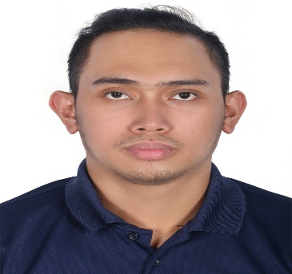

**Arlo Magallanes Balles Building 1-13b Al Khail Gate 1, Al Qouz Industrial area 2**

**Dubai**

**+971563642781**

**[ballesarlo12@gmail.com/arloballes@yahoo.com](mailto:ballesarlo12@gmail.com/arloballes@yahoo.com)**

# OBJECTIVE

To be a part of a company where I can have an opportunity for Growth and development, and to be able to contribute my skill and capacity in the company’s work objectives and goals.

# SKILLS

* Computer Troubleshooting
* Microsoft Word, Excel and Power Point
* Good written and oral communication skills
* Ability to work under pressure with minimal supervision
* Team leadership
* Ability to work effectively under team settings

|  |  |
| --- | --- |
|  | **PERSONAL INFORMATION** |
| Age: | 29 years old |
| Date of Birth: | October 14, 1994 |
| Civil Status: | Married |
| Citizenship: | Filipino |
|  | **WORK EXPERIENCE** |

## Cravia LLC. UAE (Cinnabon)

Store-Incharge

Barista, Waiter, Cashier, Barista & Baker

October 14, 2017 – October 14, 2023

### Duties and Responsibilities

* Preparing and serving hot and cold drinks such as coffee, tea, artisan and special beverages.
* Cleaning and sanitizing work areas, utensils and equipment’s
* Cleaning and seating area.
* Describing menu items and suggesting products to customers.
* Speaking to customers to quickly get to the root of their problem.
* Servicing customers and taking orders.
* Ordering, Receiving and distributing stock supplies.
* Receiving and processing customer.
* A happy, friendly personality.
* Positive and approachable manner.

The French Baker Inc.

Service Crew (Baker / Kitchen)

October 05, 2013 – August 09, 2017

Making Breads (Baguette, Ciabatta etc.)

Pastries (Croissants, Danish etc.)

# EDUCATIONAL BACKGROUND

|  |  |
| --- | --- |
|  |  |
| **COLLEGE:** | Datamex College of Saint Adeline (Sucat Branch |
|  | Information Technology (I.T.) |
|  | 2011-2013 |
| **SECONDARY:** | Paranaque National High School ( PNHS ) |
|  | Sucat Paranaque City |
|  | 2007-2011 |
|  |  |
|  |  |
|  |  |

I hereby certainly that above information is true and correct.

***Arlo Magallanes Balles***

Applicants Signature