RESUME

ASHIF VENGOLI PURATH

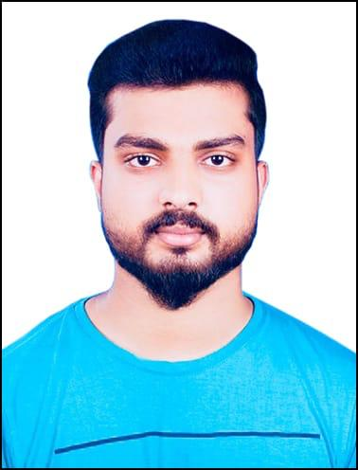  PERSONAL PROFILE  ASHIF VENGOLI PURATH  E-mail:-  ashifzain99@gmail.com  Mobile:-  +971-566516529  +91-9961761701  Address for communication:-  Al Rafaa Street,  Near Bur Dubai Taxi Stand , Dubai  Personal data :-  Date of Birth :11.04.1995  Gender : Male  Status : Married Nationality : Indian  Religion : Muslim  Blood Group : B +ve  Visa Status :-  - Visit Visa  Exp : 19/02/2022  Language known :-  - English  - Hindi  - Malayalam  - Arabic  - Tamil  Personal Interest :-  - Driving  - Travelling  - Play  - Music  Personal Strength :-  - Good understanding ability  - Team leadership  - Ability to work in a team  - Much better working approach  - Hard working | CARRIER OBJECTIVE :  Intend to build a career with leading corporate of hi-tech environment with committed & dedicated people, which will help me to explore myself fully and realize my potential. Willing to work as a key player in challenging & creative environment.  ACADAMIC S :  Course : Higher Secondary School  Institute : KMO Higher Secondary School  Year of passing : 2014  Course : Secondary School  Institute : CHSS MADAVOOR Year of passing : 2012  PROFESSIONAL EXPERIENCE :  Company : LULU Hyper Market Dubai ,  Designation : Sales Person  Duration : 2016 to 2020  Company : Western International LLC  Designation : Merchandiser  Duration : 2020 to 2021  SOFTAWARE SKILLS :  - Basic knowledge of Computer  - Thorough knowledge in MS excel and MS Word  KEY SKILLS :  - Excellent spoken & written skills over 3 languages  - creative thinking  - Confidence to sell your ideas  - attention to detail  - ability to drive and motive a team  POSITIVE STRENGTHS :  I like to face new challenges and like to do the hard work in smart way. Discipline, devotion, determination are my best friends. I am an effective communicator, good listener, quick learner and silent performer too. I do believe in "Action speaks louder than words".  DECLERATION :  I do hereby declare that all the information’s furnished above are true to the best of my knowledge.  Ashif Vengoli Purath

