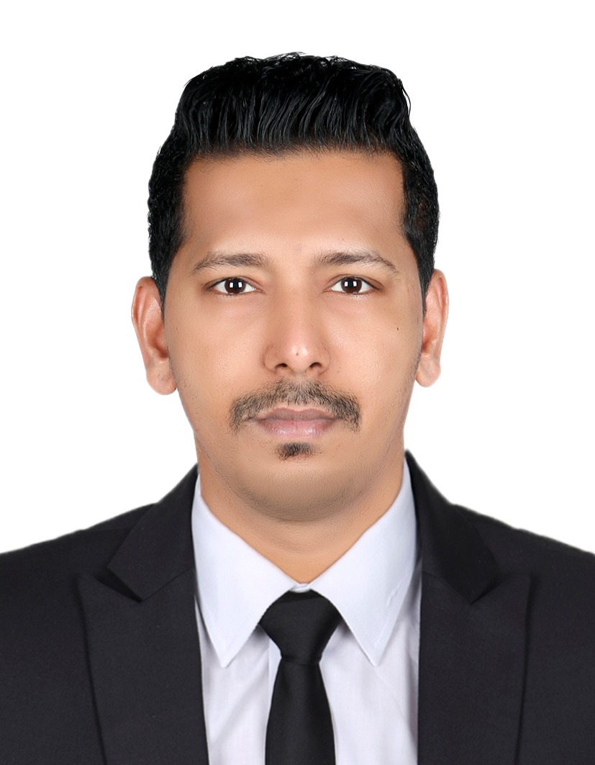

**SHAIK ABDUL AZIZ**

Mobile No.: +971509855810 / +971551913582

Location: Dubai, UAE

Email: sameershaikh200786@gmail.com

**PROFILE**

To work in a recognized Organization with a challenging and rewarding position that will enable me to utilize my knowledge, skills and experiences which could also contribute to the growth and improvement of the company

**PROFESSIONAL EXPERIENCE**

**Alchemy Cosmetics Trading**

**Sales Executive/Delivery Driver**

November 5th 2022 till date

**Right Buy Supermarket**

**Cashier / Merchandiser**

June 15rd 2021 till September 10th 2022

**F. Mart Supermarket LLC**

**Cashier / Outlet In-charge**

December 23rd 2016 till June 12th 2019

**Caractere Group of Salon**

**Cashier**

November 17th 2014 till November 17th 2016

**EDUCATION**

**Matriculation - Arts**

June 7th 1999 to June 10th 2009

**Anjuman High School**

Goa Board, Goa India.

**OTHER SKILLS**

* Terrific customer service skills
* Capable of handling numerous tasks simultaneously
* Fluent in English, Hindi Arabic
* Having good knowledge of products(Food & Beverages and FMCG’S)
* Time management
* Well Conversant in Communication, Analytical & Interpersonal Skills
* Ability to work well in a team
* Math’s skills for handling payments
* A strong work ethic and desire to succeed
* Knowledge of cataloging and inventory techniques.

**PERSONAL INFO**

* *Nationality : Indian*
* *Passport No. : L5649464*
* *Date of Birth : 20/07/1986*
* *Visa Status : Canceled Visa*
* *UAE Driving License : No. 3 Manual*

**SHAIK ABDUL AZIZ**

APPLICANT