*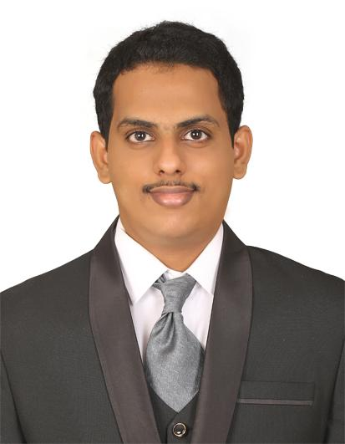SP Oasis*

*Dubai Silicon Oasis*

*+971507786134*

[*arbhb@outlook.com*](mailto:arbhb@outlook.com)

*www.linkedin.com/in/arbh07*

Abdul Rahman Bin Hussein BaataA long, thin rectangle to divide sections of the document

*Implemented data-driven process improvements in Process Executive Data role resulting in a 20% increase in efficiency and productivity reduced turnaround time for data analysis by 30%.*

# **SKILLS**

*Microsoft Excel, Financial Analysis,Tax Planning,Process Optimization*

# **EXPERIENCE**

## COP28 Dubai *— Volunteer*

12/2023 - 12/2023

* *Enhanced productivity by efficiently completing assigned tasks without direct supervision, resulting in a 20% decrease in turnaround time and a 15% increase in task completion rate.*
* *Processed and executed a safety audit program, resulting in a 30% decrease in workplace hazards and ensuring compliance with industry safety standards.*
* *Implemented a comprehensive feedback collection system, resulting in a 25% increase in visitor satisfaction scores and a 20% improvement in overall visitor experience.*

## ICICI BANK Hyderabad *— Assistant Manager II*

05/2023 - 09/2023

* *Conducted in-depth financial consultations with customers, analyzing goals and objectives, and recommending appropriate financial solutions, resulting in a 20% increase in portfolio growth and a 10% increase in revenue.*
* *Directed and implemented comprehensive 360-degree banking solutions for individuals, professionals, and businesses, resulting in a 25% increase in new customer acquisition within the first quarter.*
* *Analyzed and reconciled bank statements for a portfolio of 50+ clients, ensuring accuracy and identifying discrepancies, resulting in improved financial integrity and client satisfaction.*
* *Orchestrated a company-wide organizational overhaul, implementing new systems and processes that streamlined operations and increased overall efficiency by 40%.*
* *Implemented a customer relationship management (CRM) system, streamlining the sales process and increasing conversion rates by 20%.*
* *Collaborated with cross-functional teams to develop and implement data entry best practices, resulting in a 25% increase in data accuracy across the organization.*

## COGNIZANT TECHNOLOGIES SOLUTIONS Hyderabad *— Process Executive*

10/2019 - 10/2022

* *Spearheaded a cross-functional initiative to optimize transactional processes, collaborating with stakeholders to implement system enhancements that reduced manual efforts by 40% and saved 20 hours per week.*
* *Led a cross-functional team to develop and launch a loyalty program, increasing customer retention by 25% and driving repeat business.*
* *Achieved and exceeded process SLAs and quality targets by steadily meeting productivity metrics within established timelines, resulting in a team efficiency improvement of 20% and a 15% reduction in customer support issues.*
* *Led cross-functional teams in the successful implementation of a centralized document management system, resulting in a 30% decrease in document retrieval time and improved collaboration across departments*
* *Orchestrated the implementation of industry-leading security protocols and procedures, resulting in a 40% reduction in security incidents and safeguarding sensitive customer data.*
* *Identified and proactively addressed process-related inefficiencies with team leaders and managers, resulting in a 20% reduction in average resolution time and a 15% increase in customer satisfaction scores.*
* *Streamlined transaction processing by preventively staying updated with process knowledge through regular review of knowledge repositories, resulting in a 25% reduction in transaction errors and improved customer satisfaction.*
* *Conceptualized data tracking tools to capture and evaluate production statistics, customer feedback, and market trends, leading to the implementation of targeted process enhancements, resulting in a 10% boost in product quality.*
* *Spearheaded the implementation of Microsoft Office suite across the organization, training 50+ employees and improving cross-functional collaboration and productivity by 40%.*

## HRH NEXT SERVICES Hyderabad *— Customer Care Executive*

03/2018 - 11/2018

* *Welcomed customers with a warm and observant approach, ensuring immediate satisfaction and fostering positive brand experiences; resulted in a 15% increase in customer retention and a 10% boost in customer satisfaction ratings.*
* *Led cross-functional team in developing and launching a customer feedback program, resulting in a 40% increase in customer feedback response rate and valuable insights used to improve product features.*
* *Resolved 50+ customer queries daily over the phone, achieving a 95% customer satisfaction rating and reducing average call duration by 20%.*
* *Developed and delivered specialized customer service training program, equipping the team with advanced conflict resolution skills and reducing escalations by 35%*.
* *Implemented a customer loyalty program, resulting in a 15% increase in customer retention and a 25% increase in customer lifetime value.*
* *Analyzed sales data and created detailed reports to optimize pricing strategies, leading to a 10% increase in ticket sales and a 5% growth in revenue within the first quarter.*

# EDUCATION

## Osmania University Hyderabad *— MBA Finance*

09/2019 - 09/2021

## Osmania University Hyderabad *— B.COM Computers*

06/2014 - 05/2017

# LANGUAGES

*ENGLISH*

*URDU*

*ARABIC*

# AWARDS

*Streamlined defect resolution process,resulting in 95% reduction in customer support issues and recognition with a certificate of appreciation for delivering timely solutions and improving customer satisfaction.*

*Implemented a proactive customer service approach,resulting in 15% decrease in customer complaints and a 20% increase in customer loyalty.*

# CERTIFICATIONS

*ChatGPT in Smart Learning* (10/2023 - 10/2023)

*Financial Accounting* (11/2023 - 11/2023)

*UAE VAT Course* (12/2023 - 12/2023)