***ITAE***

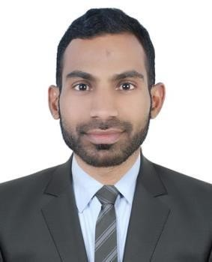

***URRICULUM***

**ABDULLA**

**THALAYILLATH**



**+971**

**54**

**5003803**



**+971 56**

**3894730**

**Dubai**

**UAE**

**Email:**

**saheeredachakai786@gmail.com**

**OBJECTIVE**

A Suitable position with an organization where I can Utilize the best of my skills and abilities that fit to my Education, skills and experience a place where an encouraged and permitted to be an active participant as well vital contribute on development of the Company

|  |  |  |
| --- | --- | --- |
| **PERSONAL PROFILES:** |  | |
| Name  Date of Birth  Nationality  Gender  Religion  Marital Status  Languages Known  Visa Status | : **ABDULLA THALAYILLATH**  : 20-11-1988  : Indian  : Male  : Muslim  : Married  : English, Hindi  : **Visiting visa expired on:18th march 2023** | |
| **EDUCATION QUALIFICATION:** | |  |

* **(12th)Intermediate Passed**

|  |  |
| --- | --- |
| **PROFESSIONAL QUALIFICATION:** |  |

* **MS Office**
* **Internet & Browsing**
* **Certificate in Senior Salesman**
* **Computer Typing Course**
* **Certificate in HUNAR SE ROZGAR in Government in India**
* **Certificate in TALLY**
* **Certificate in Vocational Training Organization**

|  |  |
| --- | --- |
| **PERSONAL SKILLS:** |  |

* Good team Spirit and Hard Working Nature 
* Punctual focused and very dedicated to any task given 
* Expert in performing repetitive tasks speedily and carefully 
* Always follow safety rules & regulations 

|  |  |
| --- | --- |
| **PROFESSIONAL EXPERIENCE IN GULF:** |  |

▪working as assistant document controller with EPL SHIPPILG LLC, Dubai airport free zone

|  |  |  |
| --- | --- | --- |
| ▪ Worked as a **“sales man”** with | **NESTO HYPER MARKET** |  |

**LLC** **in Dubai UAE,5years.**

▪ Worked as a **“Data Entry Operator”** with **MARFA TECHNOLOGIES LLC**, **in Dubai UAE 2 years**.

|  |  |
| --- | --- |
| **CONCLUSION & DECLARATION:** |  |

I hereby certify that the above mentioned Statement is correct & true to the best of my knowledge & belief.

# ABDULLA THALAYILLATH