**USA Compliance & Fleet Specialist| Jan 2024 – Continue**

Metropolitan Warehouse and Delivery

* Managed the Fleet Mentor System
* Worked on Samsara Fleet
* Managed Do it Right Screening

**Supply Chain Manager| 2020 – 2023**

Nawak Enterprises, Islamabad

* + - * Leveraged planning knowledge to drive supply chain activities through the creation, modification, and implementation of production plans.
      * Managed SKUs for machinery parts and tools.
      * Created and launched supplier scorecard and supplier survey.
      * Saved 0.5 million Pkr by eliminating constraints in the Furnace process.
      * Reduced high-flame burner cost by 10% through changing to tyre oil from furnace oil

**Assistant Supply Chain Manager | 2019 – 2020**

Nawak Enterprises, Islamabad

* + - * Responsible for maintaining and updating internal Supply Chain databases.
      * Encourage staff and coordinate resources to assist senior managers
      * Prepared purchase orders and send to suppliers
      * Established and maintained supplier relations.
      * Maintained records for materials received.

**Marketing Manager | 2017 – 2019**

Nawak Enterprises, Islamabad

* + - * Developing strategies and tactics to boost the company’s reputarían and drive qualified traffic.
      * Deploying successful marketing campaigns from ideation to execution

**Assistant Marketing Manager** **| 2016 – 2017**

Nawak Enterprises, Islamabad

Developed strategy and managed customer communication, helped marketing manager in achieving organization goals.

**WORK EXPERIENCE**

**DIPLOMAS Y HOBBIES**

**Formaciones :** Diplomados, Congresos, xxxxxxxxxxxxxxxxxxxxxxxxxxxxxxxxxxxxxxxxxx

**Hobbies:**xxxxxxxxxxxxxxxxxxxxxxxxxxxxxx

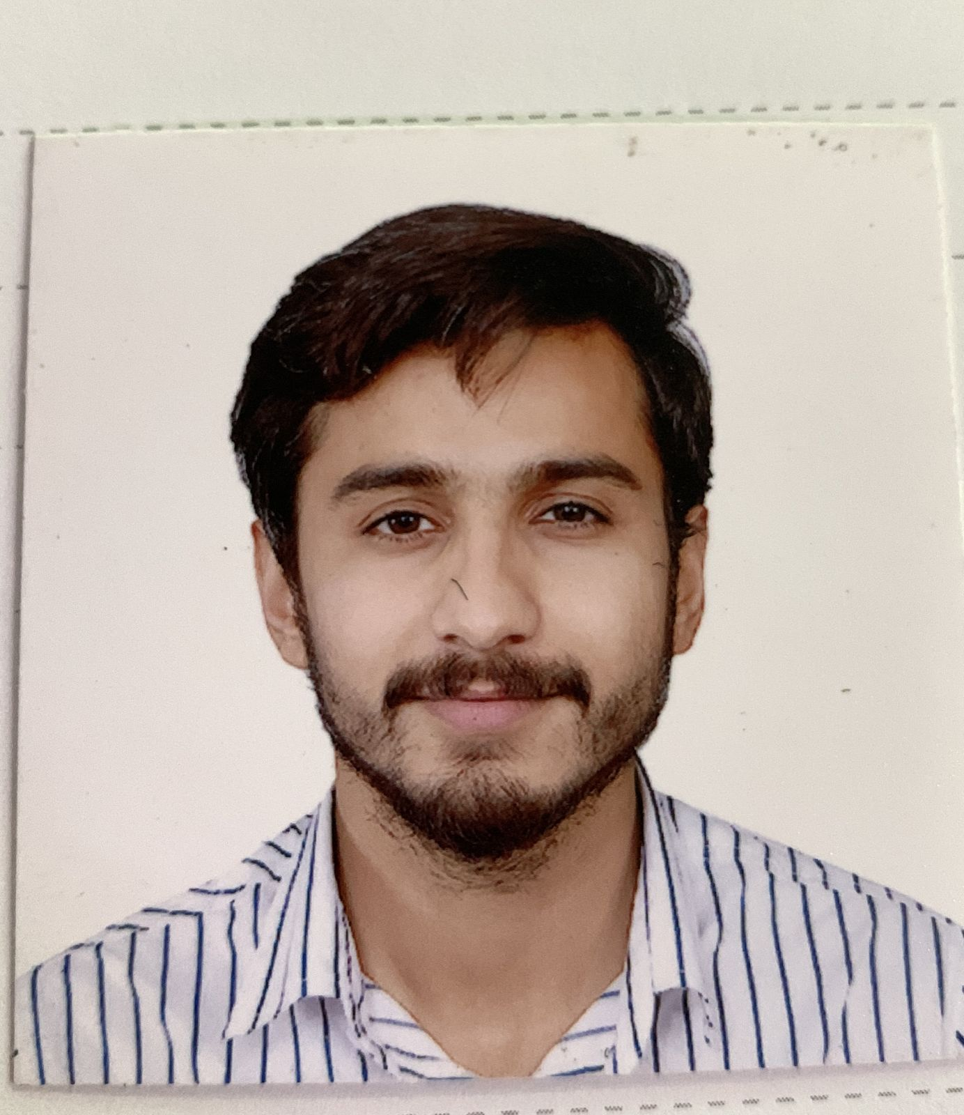

**Abdullah Khalid**

Supply Chain Manager

USA COMPLIANCE ASSISTANT

**ABOUT ME**

Organized supply chain manager with 5+ years of experience reducing cost and increasing service quality. Seeking to create productive partnerships. At Nawak Enterprises, reduced parts branding costs $10K via packaging design and strategy..

**SKILLS**



**LANGUAGES**

+923315124324

Abdullah.khalid1311@gmail.com

Islamabad, Pakistan

**CONTACT**

• Process Improvement

• Project Management

• Supply Chain Solutions

• Strategic Planning

• Mentorship

• Planning Skills

• Time Management

• Multi-tasking

2020-2023 Islamabad - Pakistan

**Masters of Science in Supply Chain Manager**

Riphah International University

2019 | Islamabad - Pakistan

**BBA Hons. Marketing**

Capital University of science and technology

**EDUCATION**

English: Proficient

Urdu: Native

©AZURIUS - My-resume-templates.com