C:\Users\HP\Desktop\people_9270893.pngE:\icons\global.pngC:\Users\HP\Desktop\people_9270893.pngC:\Users\HP\Desktop\calendar-day_9586166.pngC:\Users\HP\Desktop\house-chimney_9246364.png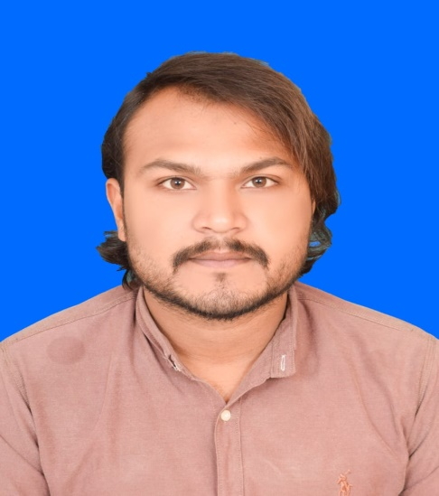E:\icons\black-back-closed-envelope-shape.pngE:\icons\man-user.pngE:\icons\old-handphone.png

* **3D MAX + VRAY (Aug 2022 – Dec 2022)**

New Age Institute of Management Science Lahore, Pakistan

* **Clinical Assistant (Jan 2020 – Oct 2021)**

Punjab Vocational Training Institute Dr. Muzaffar Saeed Muzaffargarh, Pakistan

**EDUCATION**

**Hindi** Advance

**Language**

Playing Cricket

Traveling

Reading Books

**Interests**

**Marital Status**

Single

**Nationality**

Pakistan

**Date of Birth**

05-03-2000

**Email**

Arkking88@gmail.com

**Address**

Dubai, UAE

**Name**

Ali Raza

**Persona**l

* **Sales Officer (Jul 2020 – Mar 2023)**

Faisal Enterprises (Pharmaceutical Distribution), Pakistan

* Problem-solving
* Basic internet navigation and research skills
* Time Management
* 3D MAX Studio+ VRAY
* Auto CAD 2D+3D

References available on request

**REFERENCES**

* Email
* Sales and Marketing
* Data Entry
* Microsoft Office
* **DCS (***Advance Diploma in Computer Science***) (Sep 2015 – Mar 2016)**

City Hall Institute Muzaffargarh, Pakistan

* **Auto CAD 2D+3D (Apr 2019 – Oct 2019)**

New Age Institute of Management Science Lahore, Pakistan

* Teamwork and Collaboration
* Communication

**SKILLS**

**COURSES**

* **Matriculation (Jul 2017)**

Board of Intermediate & Secondary Education Dera Ghazi Khan, Pakistan

* **Intermediate (Jan 2022)**

Board of Intermediate & Secondary Education Dera Ghazi Khan, Pakistan

**WORK EXPEREINCE**

* **Sales Man (Feb 2017 – Nov 2019)**

Pak Green Pharmacy, Pakistan

* **Clinical Assistant (Jan 2021 – Dec 2022)**

Dr. Ejaz Husain Shah M.B.B.S, F.C.P.S (Medicine), Pakistan

* **Dnata Store Assistant (April 2023 – Currently)**

Transguard Group L.L.C, Dubai UAE

ALI RAZA

I am energetic, confident, and loyal and always keen to learn new things would like to be part of dynamic organization, highly creative with the ability to work well within a team.

**Phone Number**

0523105453

**Gender**

Male

**Urdu** Native

**English** Fluent