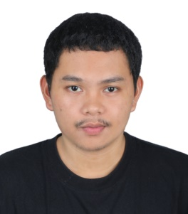

ANDRE DELIJERO ANONUEVO

Address: Dubai, UAE

Contact/Whatsapp #: 0553368645

E-mail*:* ***anonuevoandre1813@gmail.com***

### PERSONAL INFORMATION:

Birthday: March 13, 2000

Age: 24 y/o

Marital Status: Married

Nationality: Filipino

Language Spoken: Filipino/ English/ Beginner’s Arabic

### CAREER OBJECTIVE:

I seek challenging opportunities where I can fully utilize my skills and expertise for the success of the organization and

Myself professionally.

**PERSONAL SKILLS AND QUALITIES**

**\***Interpersonal Skills

*Active Listening

*Determination

*Communication

*Honesty

*Always have room for growth

**UAE EXPERIENCE:**

**MISK AL SHAM ROASTRY/SUPERMARKET**

13/06/2023 – Present

*Supermarket Stock keeper

*Salesman

*Displayer

# PHILIPPINES EXPERIENCE:

# SIOSION’S SUPERMARKET

# 09/02/2022 – 30/08/2022

# *Salesman

# *Grocery Bagger

# *Cleaner

# CUSINA NI HAPON RESTAURANT

# 03/10/2022 – 15/05/2023

# *Waiter

# *Dishwasher

# *Receptionist

# *Kitchen Helper

# 

**EDUCATIONAL BACKGROUND**

Tertiary

Marine Steward (2 Year Vocational Course)

Rizal Marine and Techno Computer College

Rizal, Philippines

2018 – 2020

Secondary Education

Senior High School Graduate

Malaya Integrated High School

Rizal, Philippines

**TRAININGS**

TESDA Electrical Installation and Maintenance

Basic Firefighting

Basic First Aid