DETAILS

ADDRESS

Dubai

United Arab Emirates

PHONE

+971528572692

EMAIL

i_asad1@yahoo.com

LINKS

linkedin.com/in/asad-iqbal-17710b1

SKILLS

Computer Skills

Ability to Work in a Team

Ability to Work Under Pressure

Microsoft Office

Teamwork

Multitasking Skills

Problem Solving Skills

Excellent Communication Skills

Customer Service Skills

Office Administration

HOBBIES

History , Movies , Sports

LANGUAGES
ASAD IQBAL
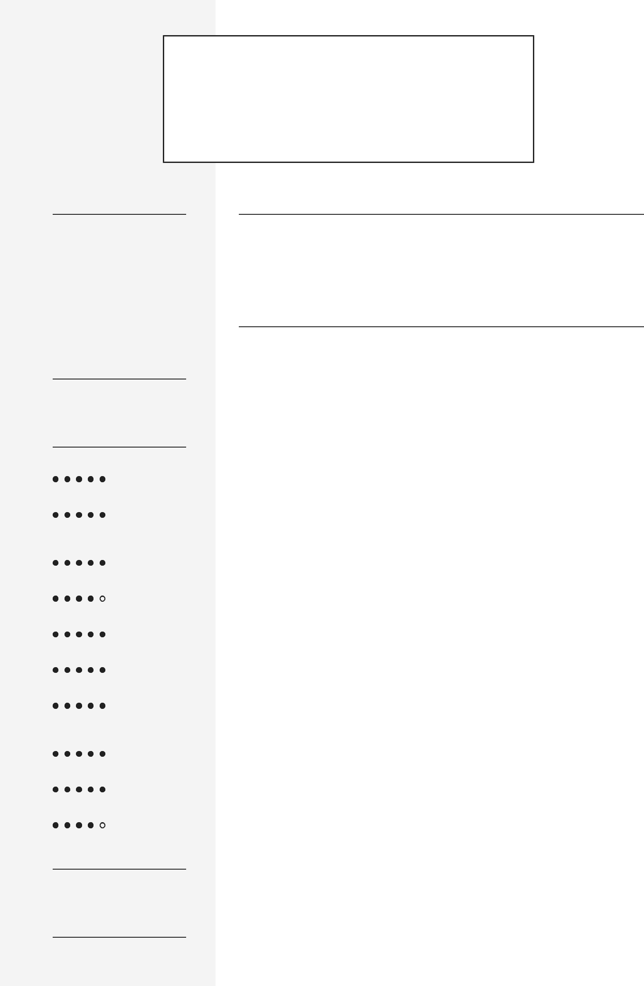

CUSTOMER SERVICE AND ADMIN

PROFILE

Team-oriented individual and well-organized with 5+ years of experience in administration and customer service. Hardworking team player with expertise, completing various clerical and administrative tasks, and offering staff support. Responsible, punctual, and productive professional working.

EMPLOYMENT HISTORY

Customer Services cum Chauffer , Transguard Group LLc , Dubai

2020

Identified, researched, and resolved customer issues using the computer system .

Provided customers with service information.

Offered advice and assistance to customers, paying attention to special needs or wants.

Followed-up on customer inquiries was immediately resolved.

Completed call logs and reports.

Researched billing issues.

Researched misapplied payments.

Demonstrated a consistent record of pick up and drop off in time.

Communicate directly with residents regarding scheduling and schedule changes, or special requests.

Transport residents to and inform them of appointments as needed.Identified problems , diagnosed causes and determined corrective actions.

Administration Assistant , Hanz Bus Rental LLc Dubai

2015 — 2020

Performing general administration and clerical duties within the organization.

Prepare customer files and keep records of history.

Schedule meetings, interviews, training and conference calls as requested by the managers.

Assist the transportation Fleet Director with department administration requirements and duties.

Sort and handle both incoming and outgoing mail. Ensuring office procedures and systems operate efficiently.

Handling requests for information and data.

Assisted the new staff with learning the file control system.

Assisted in preparing directory listings for quick identification and location of the files in the data bank.


English

Arabic

Urdu

phostu

Hindi
Maintain documentation of general office activities and business transactions to ensure easy accessibility of information.

Performance Appraisal Activities by MBO and EPM.

Managing employee data on HRIS or HRMS.

Accountant General , Hanz Bus Rental LLc Dubai

2012 — 2015

Operating computers program with accounting software to record, store, and analyze information .

Checked figures , postings, and documents for correct entry , mathematical accuracy, and proper codes.

Recorded expenses and maintained accounting records in Excel.

Managed financial departments with responsibility for Budgets, Forecasting, Payroll, Accounts Payable, and Receivable.

Recording employee overtime hours into an Excel spreadsheet.

Maintained records of all reports, such as audit reports, financial statements, and revenue and sales statements.

Prepared annual company accounts and reports.

Prepare invoices for transportation for the customer .

Analyzed and prepared monthly and annual profit and loss statements and a balance sheet .

EDUCATION

Master of Business Administration , City University of | Peshawar
sciences information and technology
Aug 2006 — Feb 2009
GPA 3.03
Bachelor in computer sciences , University of | Peshawar
Peshawar
Jun 2003 — Jul 2006
A Grade
EXTRA-CURRICULAR ACTIVITIES
Organizer, Pakistan Consulate Dubai | Dubai
2015 — 2018
REFERENCES
Junid Khan from Emirates Driving Institue
971523205673
Hukam Saeed from Fortune Bus Rental LLc
00971506778190

COURSES


Diploma in Information Technology , Frontier

College

Jun 2003 — Aug 2004

Customer Services , Emirates Airline

2020 — 2020

Fire Fighting , Emirates Airline

2020 — 2020

CPR and First Aid , Emirates Airline

2020 — 2020

INTERNSHIPS

Intreship, National Bank of Pakistan Charsadda

2008 — 2009

