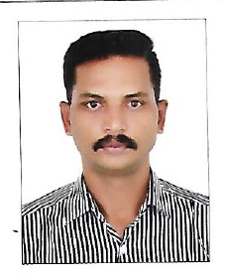
Muhammed Azad M
Salesman and Purchaser
DUBAI, UAE

Email:Anvaradhil11@gmail.com
Mob: +971 542234065

Profile :
  - Diligent Salesman and Purchaser regularly maintain inventory to meet vendor product supply requirements and properly fulfill orders. Maintains market awareness by communicating Customer needs with buyer on sales terms. Liaises with buyer to determine specialty order pricing and Out-of-stock item estimated delivery and freight costs to meet customer expectations. To seek and maintain full Time position that offers professional challenges utilizing Interpersonal kills, excellent time management and problem-solving skills.
Key Skills :
- Eye for detail.
- Excellent negotiation skill.
- Safety standards and protocols.
- Decision Making.
- Client Relation.
- Complaint Handling.

Professional Experience :
Salesman and Purchaser.
(January 2007 to December 2022)

Fadek International Company, Riyadh

- Maintained complete documentation and record of all purchasing activities.
- Negotiated policies and contracts with vendors to achieve optimal pricing and consistent availability.

- ability to thoroughly understand and effectively communicate the features, benefits, and applications of products to potential customers.
- Skillful at actively listening to customer needs and preferences, tailoring recommendations to match their requirements and fostering rapport.
- Keen eye for detail when processing orders, managing inventory, and ensuring accuracy in pricing and billing.
- Experienced in identifying and addressing customer issues, finding swift and effective solutions, and maintaining customer satisfaction.
Education :

- Higher Secondary
St Stephens HS Pathanapuram.
1994 – 1996

Personal details :

- Date of Birth : 20th May 1977
- Nationality : Indian
- Languages : Arabic, English, Hindi, Malayalam & Tamil.
- Passport Number : N8199729
- Passport Expiry : 05th April 2026
- Visa status : Visit Visa
- Visa Expiry : 26th September 2023

Declaration :

I hereby solemnly declare that the all the statements made in the above resume are true and correct in the best of my knowledge and belief.

Muhammed Azad M

