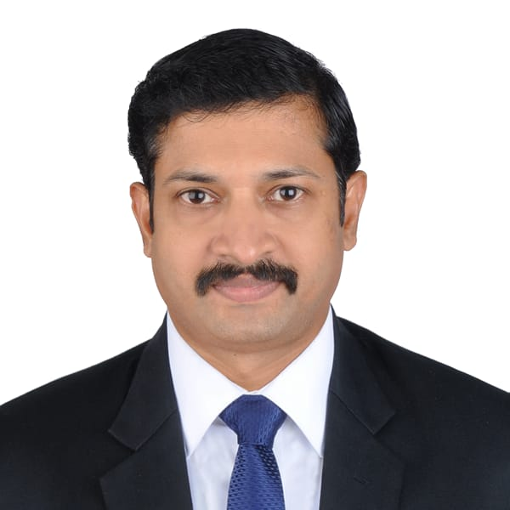

**BABURAJ KRISHNANKUTTY**

**TOTAL GCC WORK EXPERIENCE -18 YEARS (3 years UAE exp)**

**CAREER OBJECTIVE**

I would like to work in an organization where my skills will add value to oper ations. A position where performance is rewarded with more responsibilities.

**EXPERIENCE**

**Designation : TECHNICAL ASSISTANT for Water Emergency & Water maintenance underthe contract # GTC/938/2017 with Qatar General Electricity&Watercorporation (KAHRAMAA)**

**Organization: PS Tech WLL, Doha, Qatar.**

**Duration:-20-02- 2019 to 29-02-2024**

**Duties/Responsibilities:**

* Records all incoming & outgoing correspondence, photocopying, filing records etc for Senior Maintenance Engineer - Pipeline (SME/PL) & all Maintenance Engineers & Emergency Engineers.
* Assists Senior Maintenance Engineer - Pipeline in his routine official duties.
* To inform all official/scheduled meetings to SME/PL.
* Received all incoming fax messages and passed to SME/PL. Send out faxes to the concerned Sections.
* Maintains Electronic files as per directory-wise in the Computer for various correspondence and reports of the Division.
* Assists inthe word processing works of major reports/specifications /schedules and binding and distribution of reports.
* Administrative and technical duties pertaining to clerical issues.
* Attend meeting & prepares minutes of meeting.
* Answers and screens all incoming telephone calls, Filing system.
* Assist Emergency Shift Supervisor to dispatches received complaints from,, Call Centre" to Field Inspectors during his shift.
* Communicates & Coordinates Field Inspectors, water Tanker Drivers, "Operations Section" to operate the valves and "Transport Section" to arrange Tanker and other equipment's.
* Compiles spreadsheets for analytical purposes.

**Designation :-Electrical Substation Operator in KAHRAMAA primary Substations under the contract # GTC/729/2015 with Qatar General Electricity & Water Corporation (KAHRAMAA)**

**Organization: PS Tech WLL, Doha, Qatar.**

**Duration: 14-03-2012 to 12-01- 2019**

**Duties/Responsibilities:**

* Experienced in substation duties and activities including Inspection, monitoring and overall supervision of 400/220/132/66/11 kV substations.
* Inspecting the transformers and reactors for oil leaks and check oil level, oil temperature, winding temperature etc.
* Check overall physical conditions of transformers and reactors including radiators and sampling valves.
* Inspect cooling control cubicle and check the working of cooling fans and healthiness of mcb’s for cooling pumps.
* Inspect Tap Changer cubicles and check tap position.
* Inspect RTCC panel and check tap position, local remote position, individual/parallel position, healthiness of tap position indicator if any.

**+971 566928976**





babusczr@gmail.com



**1-10 AL KHAIL GATE DUBAI**

**PERSONAL DETAILS**

* Date of Birth : 29th May 1980
* Marital Status : Married
* Fathers Name : Krishnankutty
* Nationality : Indian
* Passport No : V9551756
* Place of issue : Doha
* Date of issue : 26-10-2021
* Date of expiry : 25-10-2031
* **Visa Status : Residence**
* Emirates ID No : 784-1980-3722595-4
* Qatar driving license expiry:11/10/2028

**PERSONAL SKILLS**

Comprehensive problem-solving abilities. Excellent Verbal and written communication skills, abil ity to deal with people diplomati cally, willingness to learn.

* Inspect cooling control cubicle and check the working of cooling fans and healthiness of mcb’s for cooling pumps.
* Inspect Tap Changer cubicles and check tap position.
* Inspect RTCC panel and check tap position, local remote position, individual/parallel position, healthiness of tap position indicator if any.
* Inspection of all relay panels including transformer bays, reactor bays and feeder bays, bus section, bus coupler etc.
* Check all relays if there is any alarm report to the concerned control centers.
* Visual Inspection of GIS and check the sf6 gas pressure monitor/meter whether it is in normal range.
* Inspect GIS and check the name plates of newly energized feeders are fixed.
* Check “on – off” status of CB’s, line isolators, bus isolators, line earth switches, maintenance earth switches etc are visible and correct.
* Check all 11 kV feeder loads, bus bar voltage, transformer tap positions and record the values in station log.
* Inspection of 11kV switch gear room and check all energized 11 kV switch gear panels have circuit label.
* Checks the lamp indications on the 11KV panels are healthy.
* Check the local remote status of the 11kv feeder control and check all pad locks are available.
* Inspect 11kV switchgear panel and check springs are charged and earth switch & breaker status indications are correct.
* Check visible parts of body of panels for corrosion or defective paint work.
* Visual inspection of cable basement and check for abnormalities if any.
* Inspect LVAC panels and check the status of incomer ACB’s and bus section ACB, if any ACB is found tripped immediately report to control.
* Check all lamp indications and switch gear status indicators, ammeters and voltmeters are correct and working.
* Visual Inspection of Battery charger panel check the ammeter and volt meter reading, and check if any alarms are present.
* Inspect battery banks and check if any batteries are bulged or damaged.
* Inspect the fire panel and FM 200 panel, check if any alarms are present.
* Check the availability of fire fighting cylinders inside the station.
* Visual checking the pump room, electrical pump, diesel pump etc and immediately report if found any abnormality.
* General Inspection and checking of substation like station gates, fencing, locks etc.
* Inspection of yard lights, indoor lights, emergency lights etc.
* Monitor the substation through Substation Control System(SCS)
* Attending emergency calls from NCC, DGCC, DCC, Forman Office and any authorized KM personal, and inspect investigate the situation and report back.
* Inspect and clear the alarms in relay panels, LVAC panels, Battery Charger, HVAC panels etc with the consent of NCC/DGCC/DCC/FM Office.
* Log all station events in station log book in chronological order.
* Make sure all working personal inside the substation have proper KM gate pass and other documents (LOA, PTW, and ATRE etc).
* Tap changing of transformers as per the instructions of System Control Engineer either from the RTCC panel or manually from TCC cubicle.
* On time reporting of alarms to the concerned departments
* Assisted maintenance and technical personals in routine system maintenance of Power & Auxiliary Transformers, Battery banks and GIS, AIS equipments such as Circuit Breakers, CTs, VTs, Isolators, Earth switch, LAs etc.
* Assisted switching Engineers in switching especially DCC engineers in manual switching operation of 11kv feeders.
* Attended Testing & commissioning and scheme modification in protection panel in different substations.
* Operation of Emergency Tripping Scheme according to the station load.
* Managing operations on LVAC Equipment Panels, Fire Protection Alarm Panels, Sergi Protection Panels, Deluge Pump System, FM200 Protection and CO2 switch gear room.
* Ensuring the quality of work and strict compliance with KAHRAMAA safety rules and protection.

**Designation : Plant office Building ELECTRICIAN**

**Organization : STRABAG QATAR,WLL for Qatar kentz in pearl GTL project**

**Duration : Dec 5,2009 to feb 18,2010.**

**Duties & Responsibilities:**

* Assemble, install, test, and maintain electrical or electronic wiring,
* equipment, appliances, apparatus, and fixtures, using hand tools and power tools
* Connect wires to Circuit breakers, transformers, or other components
* Inspect electrical systems, equipment, and components to identify
* hazards, defects and the need for adjustment or repair and to ensure compliance with code

**Designation : Substation Junior Operator**

**Organization : KERALA STATE ELECTRICITY BOARD(contract Basis) 33 KV substation Anthikad, Kerala,India**

**Duration : July 7 2009 to Dec 4 2009 and Feb 25 2010 to Mar 10 2012 (2 years).**

**Duties & Responsibilities:**

* Operation and maintenance of incomer and outgoing feeders
* Cubicles , Isolators,control panels.
* Handled various types of relays and its functioning
* Assisted testing and commissioning of equipment in substation
* Operation and maintenance of potential transformers and
* current transformers.
* Supervising battery and battery charger maintenance.
* Supervising various maintenance works at substation.

**Designation : ELECTRICIAN**

**Organization : THERMO L.L.C Dubai**

**Duration : 13th april 2006 to 16th june 2009 (3 years)**

**Duties & Responsibilities:**

* Worked with Dubai international airport terminal III
* Wiring, D.B dressing, fixing the fire alarms in multi stored buildings
* Leading panel installation and assist commissioning team.

**Designation : ELECTRICIAN**

**Organization : Premier Electrical, Thrissur, Kerala, India**

**Duration : From 1999 to 2001 (2 years)**

* Ability to trouble shoot and repair electrical systems
* Installs and repairs electrical circuits for power, lights and building equipment
* Analyzing technical issues and problems, diagnosing problems, providing support to other employees, and assisting other electricians with issues

**EDUCATIONAL QUALIFICATIONS**

* DIPLOMA (Electrical Engineering) state board of technical education Kerala, India 2006.
* I.T.I (ELECTRICIAN),National Council for Vocational training ,MINISTRY OF LABOUR,GOVERNMENT OF INDIA.2003
* DIPLOMA(Electrical Engineering),Indian Engineering Technological Society, Palakkad, Kerala, India. 1999
* Pre-Degree (IVth group)S.N.College nattika under University of Calicut 1997
* S.S.L.C(Board of Public Examinations, GOVT: of KERALA).1995

**SOFTWARE EXPOSURE**

* M.S.office (MS Excel, MS word) windows 7,xp,8,10
* AutoCAD level- 1, Revit MEP

**LANGUAGE**

English, Hindi, Malayalam & Tamil

**DECLARATION**

I hereby declare that the above written particulars are true to the best of my knowledge I assure you that if given a chance I will execute my work to the fullest satisfaction of my superiors.

**BABURAJ KRISHNANKUTTY**