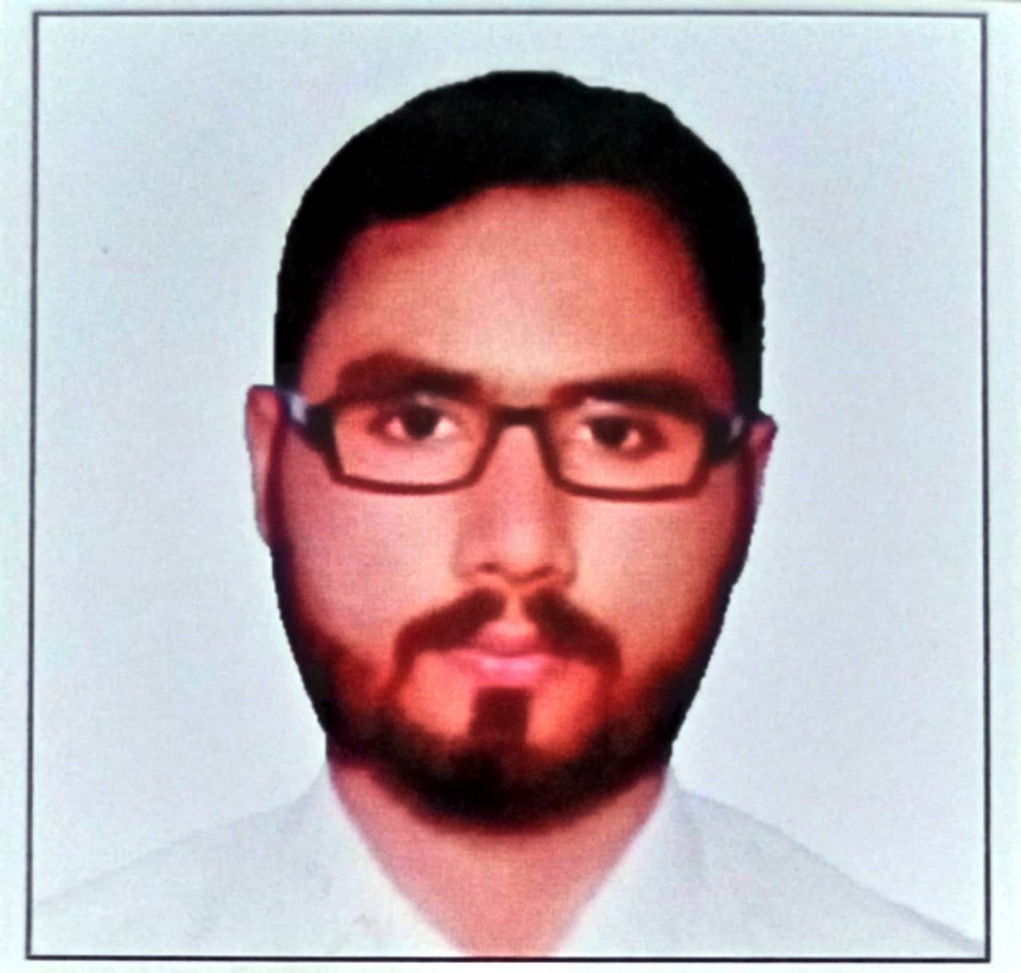 |  |  | MUhammad babar  Experience  Colgate Palmolive Pvt. Ltd. ( Oct. 2020 – Still Working )  Data Entry Clerk.  Imtiaz Super Market (2018-2020 Sep)  GRN Officer & Inventory Officer  • Unique Marketing Co. Qatar Doha (2015 & 2017)2 years  Working experience as a Marketing Representative.  Burque corporation (2012 & 2014)  Asst. Account Officer  Education  B.Com. from Karachi University (Continue)  Intermediate (Pre - Engineering)  Matriculation (Science)  Communication  As an office manager, I have honed my communication skills through years of experience in verbal and written communication with clients, vendors, and team members. I have extensive experience in creating and delivering presentations, preparing and responding to business correspondence, and ensuring effective communication throughout the office.  Leadership  I have demonstrated strong leadership skills in managing a team of administrative staff and supervising daily office operations. I have experience in providing guidance and support to staff, setting performance expectations and providing feedback, and addressing issues as they arise.  References  Available upon request.
 | Sharjah Mohella
 | +971547860333
 | Babar.qureshi146@gmail.com

Objective
To become a part of your leading and prestigious organization in order to seeking Knowledge and contribute towards innovation, growth and service. Independent professional with strong computer literacy and fast typing skills. Proficient in transcribing source data and preserving information. Seeking to achieve sustainability and growth in workforce.

