+971547078290

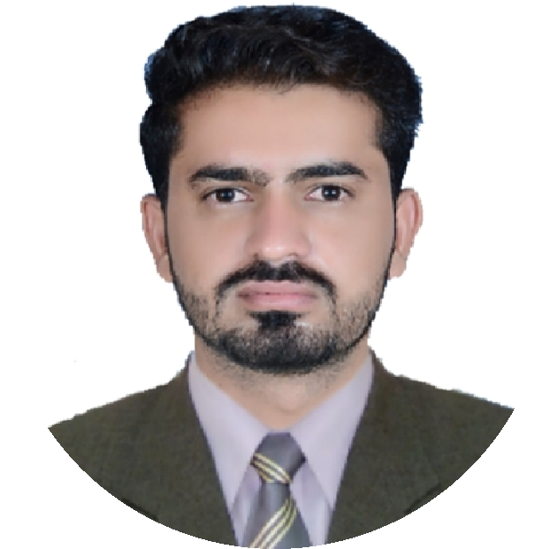

**BILAL AHMAD**

Address

Al Quoz, United Arab Emirates Email bilalbalouch542@gmail.com

English

Urdu

Hindi

Punjabi

Saraiki

Balochi

Team Leader

Customer Service

Schedule Management

Organizational Abilities

Nationality : Pakistani

Date of Birth : 01/01/1999

Marital Status: Single

Ali Garh Model College Multan, Pakistan | 2022

Seeking to leverage my strong communication and negotiation skills to contribute to a dynamic team. Eager to continue developing my expertise and making a significant impact on the company’s bottom line.

Post Graduate Diploma in Information Technology

Grade A

University of Education Lahore, Pakistan | 2021

BS English (Graduation)

CGPA 3.23/4.00

BISE Dera Ghazi Khan, Pakistan | 2016

Intermediate (Pre-Engineering ) Grade A

BISE Dera Ghazi Khan, Pakistan | 2014 Matriculation Grade B

Assistant Coordinator | 02/01/2023 - 13/01/2024

Nishat Group Of Schools and Colleges Multan:

Cashier | 01/07/2021 - 29/12/2022

Nishat Group Of Schools and Colleges Multan:

Salesman | 02/01/2023 - 13/01/2024

Global Papers & Stationery Mart Multan: Part Time Job

# Driving

Morning Walk Travelling