CATRINA C. REDONA 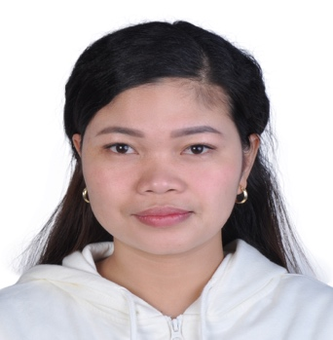

E-mail: catrinaredona59@gmail.com
Mobile: +971 559547315

Looking for a challenging role in a reputable organization to utilize my field experience, supervisory and training skills.
Career Objectives

Computer and Internet Literate
qualifications
Interpersonal skills
Organization and delegation
Forward planning and strategic thinking
Problem solving and decision-making

Store Supervisor – Pizza Hut Galleria Mall Branch
EXPERIENCE
Americana Kuwait Food and Co.
Abu Dhabi, UAE
January 2020-Present

Responsibilities:

Lead and motivate a team of employees to ensure customer satisfaction, quality standards and operational excellence.
Ensure compliance with all company policies and procedures, including safety and security protocols.
Monitor daily operations, ensuring that the restaurant is clean, well-stocked, and properly staffed.
Develop marketing strategies to increase sales and promote the restaurant’s brand.
Analyze financial data to identify areas for improvement and develop action plans to address them.
Handle costumer complaints in a professional manner, resolving issues quickly and efficiently.

Waitress/Cashier Leona Cakes and Pastries
Mabolo Cebu City, 6000 Philippines
December 2016- December 2020

Responsibilities:
Managing transactions with customers using cash registers
Collecting payments whether in cash or credit
Taking food and beverage orders and accurately entering them into the ordering system.
Performing some cleaning duties, such as at the service station, around the kitchen and in the dining area.

Sales Associate Super Metro, Mandaue City, 6014 Cebu Philippines
November 2015-December 2016

Responsibilities:

Ensure high levels of customer satisfaction through excellence sales service
Go the extra mile to get sale
Remain knowledgeable on products offered and discuss available options.
Handle returns of merchandise
Comply inventory control procedures

Diploma Food and Beverage Services, Banilad Center for Professional Development
Educational Qualification
Banilad, Cebu City 6000 Phiippines
March 2014

High School
Our Lady Academy, Ronda Cebu Philippines
March 2012

Personal Particulars
Name : Catrina C. Redona
Date of Birth : June 24, 1995
Religion : Roman Catholic
Nationality : Filipino
Marital Status : Single
Gender : Female
Language : English
Permanent Address : SKM Bldg. 23 Khalidiyah, Abu Dhabi, United Arab of Emirates
Declaration: I declare that all the information presented here are true to my knowledge. If required and where applicable, this document can be supported by appropriate authentic certificate.

