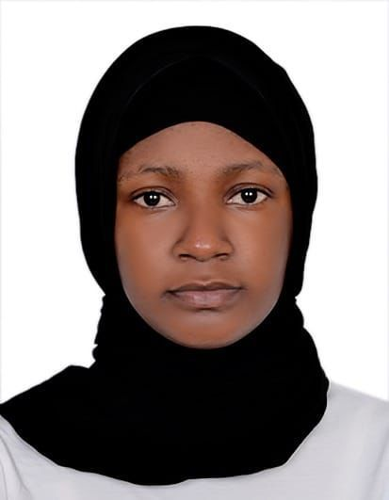

***RESUME***

**NAKAKANDE SUMAYA**

**Address:** Dubai, UAE.

**Contact No**: 0508298872

**Email:** [nakakandesumayia@gmail.com](mailto:nakakandesumayia@gmail.com)

**Visa Type**: RESIDENCE VISA

Seeking a challenging opportunity in industryfor personal and professional growth

**PROFILE**

Dedicated customer service professional with seven years working experience. Solid team work player with a positive demeanor and proven skills in establishing a rapport with clients committed to maintaining professional relationships to increase profitability and drive business results.

**CORE COMPETENCIES**

* Cold calling
* Great skills of Microsoft word and Excel.
* Ability to multi-task efficiently.
* Great skills of good team player
* Friendly disposition with clear spoken English.
* Passion for exceptional customer service.
* Ready to learn anything new.

**PROFESSIONAL EXPERIENCE**

**SHAB ADVOCATES AND LEGAL CONSULTANTS**

**DURATION: 2years**

**POSITION HELD: TELE MARKETING**

**ROLES AND RESPONBILITIES**

* Cold call people using a given phone directory to sell products or solicit donations
* Answer incoming calls from prospective customers
* Use scripts to provide information about product’s features, prices etc. and present their benefits
* Ask pertinent questions to understand the customer’s requirements
* Persuade the customer to buy by demonstrating how merchandise or services meet their needs
* Record the customer’s personal information accurately in a computer system
* Deal with complaints or doubts to safeguard the company’s reputation
* Go the “extra mile” to meet sales quota and facilitate future sales
* Keep records of calls and sales and record useful information

**BLACK LOCUS MARKETING MANAGEMENT**

**DURATION: 2years**

**POSITION HELD: SALES ASSOCIATES**

**ROLES AND RESPONBILITIES**

* Greeting customers, responding to questions, improving engagement with merchandise and providing outstanding customer service.
* Operating cash registers, managing financial transactions, and balancing drawers.
* Achieving established goals.
* Directing customers to merchandise within the store.
* Increasing in store sales.
* Superior product knowledge.
* Ability to make calls for effective communication.
* Maintaining an orderly appearance throughout the sales floor.
* Introducing promotions and opportunities to customers.

**ENTEBBE INTERNATIONAL AIRPORT.**

**DURATION: 2 YEARS**

**POSITION HELD: CUSTOMER SERVICE**

**ROLES AND RESPONBILITIES**

* Identified and assess customers’ needs to achieve satisfaction
* Built sustainable relationships and trust with customer accounts through open and interactive communication
* Provided accurate, valid and completed information by using the right methods/tools
* Meet personal/customer service team sales targets and call handling quotas
* Handled customer complaints, provided appropriate solutions and alternatives within the time limits; follow up to ensure resolution
* Kept records of customer interactions, process customer accounts and file documents

EDUCATION BACK GROUND

Bachelor’s degree in business management

* Attested Uganda advanced certificate of education.

REFFERENCE :UPON REQUEST