DIANA MAY FRANCISCO

**E**+971501975931 **ddiiaanneef@gmail.com**

Dubai, UAE

SUMMARY

Seeking opportunities where I can utilize my past work/life experiences to add value and contribute to every aspect of the company's growth

Motivated to bring authentic positive energy, adaptability, collaborative spirit and a passion for getting things done with impact and effectivity



Enthusiastic and adaptable individual with a strong background in transcription, data management, and customer service. With experience in hospitality including reception, attending to guests' needs, cleaning, waitressing in Thailand and Vietnam for a year (2018).

Proven skills in communication, research, and problem-solving, along with a keen eye for detail and an ability to work collaboratively.

EDUCATION

Bachelor of Science in Information Technology

**AMA Computer University**

 1999 - 2004



High School

**Our Lady of Perpetual Succor College**

 1995 - 1999

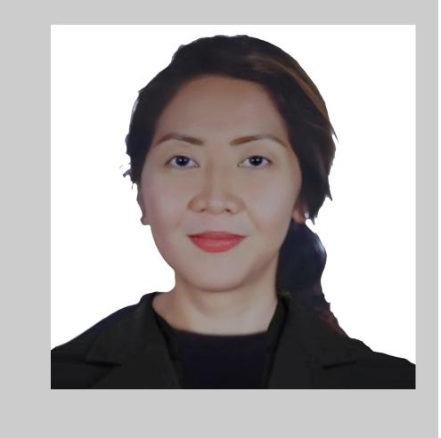

EXPERIENCE

Freelance Transcriptionist

**Rev**

 2012 - 2017  Online

Responsibilities:

* did general transcription ranging from education, financial, medical, interviews, meetings, focus groups etc.



Data Management Coordinator

**Checkwell Decisions (BackCheck)**

 2009 2011  Makati, Philippines

Responsibilities:

* data entry, checking discrepancies in documents, processing files in accordance with set guidelines, handled quality control tasks and other file management tasks as needed for an employment background checking company



Transcriber

**ScopeWorks Asia (BPO)**

 2008 - 2009  Makati, Philippines

Responsibilities:

* handled transcription tasks



SKILLS

|  |  |  |  |  |  |  |  |  |  |  |  |
| --- | --- | --- | --- | --- | --- | --- | --- | --- | --- | --- | --- |
| **Communication Skills** | | |  |  | **Research** | | | **Flexibility** | | | |
|  |  |  |  |  |  |  |  |  |  |  |  |
| **Time Management** | | | **Problem solving** | | | | |  |  | **Collaboration** | |
|  |  |  |  |  |  |  |  |  |  |  |  |

STRENGTHS

**Adaptability**

Proven ability to quickly adjust to new situations and changing demands.

**Collaborative Spirit**

Strong inclination towards working cooperatively with others to achieve common goals.

**Problem-Solving**

Skilled in identifying issues and finding effective solutions to complex problems.



**Communication Skills**

Exceptional ability to convey information clearly and effectively****Customer Service Associate

**Citibank/CitiGroup BPS**

 2006 - 2008  Makati, Philippines

Responsibilities:

* handled inbound calls for credit card and home equity account



Customer Service Representative

**iTouchPoint (BPO)**

 2005 - 2006  Libis QC, Philippines

Responsibilities:

* set up appointments for a portrait studio



Customer Service Representative

**Parlance Systems Inc. (BPO)**

 2004 - 2005  Makati, Philippines

Responsibilities:

* handled billing disputes and customer service inquiries for satellite dish account