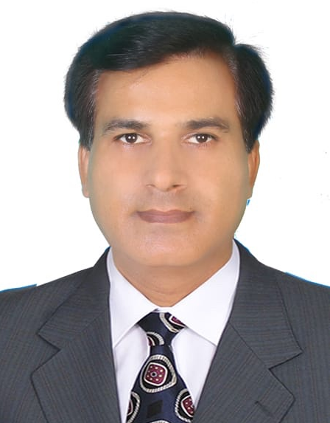
Irfan Hyder Kazi

House No. 172/173-A, Block B, Street 9, Bhitaiabad,
Gulistan-e-Jauhar, Karachi, Pakistan

Mobile #: +92-305-3135148 Watsup: +92-3053135148

Profile | Offering versatile management skills and proficiency in Microsoft Office programs. Strong planner and problem solver who adapts to change, works independently and exceeds expectations. Able to give multiple priorities for deadlines without compromising quality. Supported to most senior officers of ranked CEO, G.M and DGMs.  Worked on cost saving and productivity in different departments.

Education | MBA (Supply Chain Management)  Completed in December-2018 | From Iqra University, Karachi
Education | - 2 Years Diploma in Computer Science
Education | Professional Development:  - Leadership and Team Building - Root Cause Analyses - Communication Skills -  - People Management - Soft & Hard Skills - Safety Behavior  - How to be an Entrepreneur

Key Skills | Office Skills: | Office Management  Records Management  Database Administration | Spreadsheets/Reports  Approvals Management  Negotiation | Forwarding P.Os'  Inventory Report
Key Skills | Computer Skills: | MS Word, MS Excel  MS PowerPoint | MS Outlook  Internet | Urdu Page Software  Organizational Skills

Experience | Bolan Castings Limited  Largest foundry of Pakistan  (From 2001 to continue) | - Jul, 2001 to June 2006 - Production Plng. & Control  - Jul, 2006 to June 2009 - Marketing/Sales/Export  - Jul, 2009 to June 2012 - Training & Development  - Jul, 2012 to June 2013 - Inventory Management  - Jul, 2013 to June 2014 - ISO 9001:2015 - QMS  - Jul, 2014 to June 2016 - Finished Goods Stores  - Jul, 2017 to June 2019 - Materials Management  - Jul, 2019 to continue - MR (ISO-QMS)\Safety
Experience | Handled multifaceted tasks (e.g., records management and vendors dealing, emergency items etc.) maintained database and ensured the best to serving plant. Quickly became a trusted Deputy Manager for “can-do” attitude, flexibility and high-quality.  Worked with most senior officers to cope up the strategies of organization.
Experience | - Communicated effectively with multiple departments to plan for Purchasing and to meet the expectations of Administrative Purchasing in Organization to support the Technical works and emergency items of Plants like Gears, Sprockets and seals etc. To avoid the production delays and low productivity. Prepare welcome negotiations with suppliers to reduce the cost and continuing flow of items to regularize the feeding of machines. Established supplier relationship management to gain the support and effective results.  - To coordinate dozens of approvals for heavy machineries for plant and overseeing the two subordinates.  - Developed innovative and nearby suppliers to avoid the waste of time and to face the emergencies in plant and organizations' administrative works.  - Developed alternative sources of suppliers to avoid one source.  - Earned excellent marks on performance reviews, with citations for excellence in areas including work volume, accuracy and quality; ability to learn new concepts; positive work ethic, documentation works and commitment to service.

