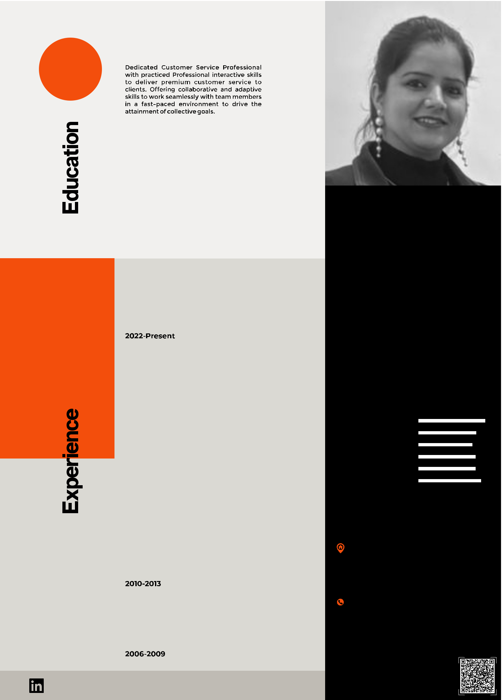**Cv About Me**

|  |  |  |  |  |
| --- | --- | --- | --- | --- |
|  |  | **Secondary - 10th** | |  |
|  |  |  | **Year of 2002-2003** |  |
|  |  | SARVODAYA GIRLS SENIOR SECONDARY SCHOOL, INDIA | |  |
|  |  |  | **Senior Secondary - 12th** |  |
|  |  |  | **Year of 2004-2005** |  |
|  |  |  | GOVT. GIRLS SENIOR SECONDARY SCHOOL, INDIA |  |
|  |  | **Graduation** | |  |
|  |  |  | **Year of 2006-2009** |  |
|  |  |  |
|  |  | BACHELOR IN ARTS FROM DELHI UNIVERSITY, INDIA | |  |
| **T** |  |  | **JP HEALTHCARE** |  |
| **E S** |  |  | **Sector-6, Parwanoo,Himachal Pradesh** |  |
| **Q U** |  |  | **Website: jphealthcare.in** |  |
| **R E** |  |  | **Company Profile: Cosmetic Manufacturing** |  |
| **N** |  |  | **Designation: HR Head/Customer Relationship Manager** |  |
|  |  |  |
| **O** |  |  |  |
|  |  |  |  |
| **AB L E** |  |  |  |  |
|  |  | **Fujiyama Power Systems Pvt. Ltd.** |  |
| **A I L** |  |  |  |
|  |  | **Sec-4, Parwanoo. Himachal Pradesh** |  |
| **A V** |  |  | **Website: www.upsinverter.com** |  |
| **E** |  |  | **Company Profile: Manufacturing Firm** |  |
| **N C** |  |  |  |
|  |  | **Designation: Admin/H.R Executive** |  |
| **R E** |  |  |  |
| **2020-2022** | | |  |
| **R E F E** |  |
|  |  |  |  |
|  |  | **JOBS EXPERTS Pvt. Ltd.** |  |
|  |  |  | **Housing Board, CHANDIGARH.** |  |
|  |  |  | **Website: www.jobsexpert.in** |  |
|  |  |  | **Company Profile: Recruitment Firm** |  |
|  |  |  | **Designation: H.R EXECUTIVE** |  |
|  | **2016-2017** | | |  |
|  |  |  |  |  |
|  |  | **SYREX INFOSERVICES (INDIA) Pvt. Ltd.** | |  |
|  |  | **Peera Garhi, NEW DELHI.** | |  |
|  |  |  |
|  |  | **Website: www.syrex.in** | |  |
|  |  | **Company Profile: BPO (Telemarketing)** | |  |
|  |  | **Designation: H.R TRAINER** | |  |
|  |  |  |  |  |
|  |  |  | **HONOUR VOICE** |  |
|  |  |  |
|  |  |  | **Janakpuri East, NEW DELHI.** |  |
|  |  |  | **Company Profile: BPO (Service Provider)** |  |
|  |  |  | **Designation: Quality Analyst** |  |

**Neha Sharma**

**CUSTOMER RELATIONSHIP MANAGER** HUMAN RESOURCE

**Skills**

Customer Relationship

Escalation Handling

Interpersonal Skills

Leadership Skills

Analytical Skills

Project Management

**Address**

Morocco Cluster, International City,, Dubai,, United Arab Emirates.

**Contact**

 E-Mail: ns.nehasharma1988@gmail.com +971 505 364055, +91 735 7620 001

Spouse Info.

MARITAL STATUS : MARRIED

HUSBAND NAME : VIKAS SHARMA

D.O.B : 24-MARCH-1988

QUALIFICATION : MBA (Marketing & Finance)

linkedin.com/in/neha-sharma-112092173