CURRICULUM VITAE

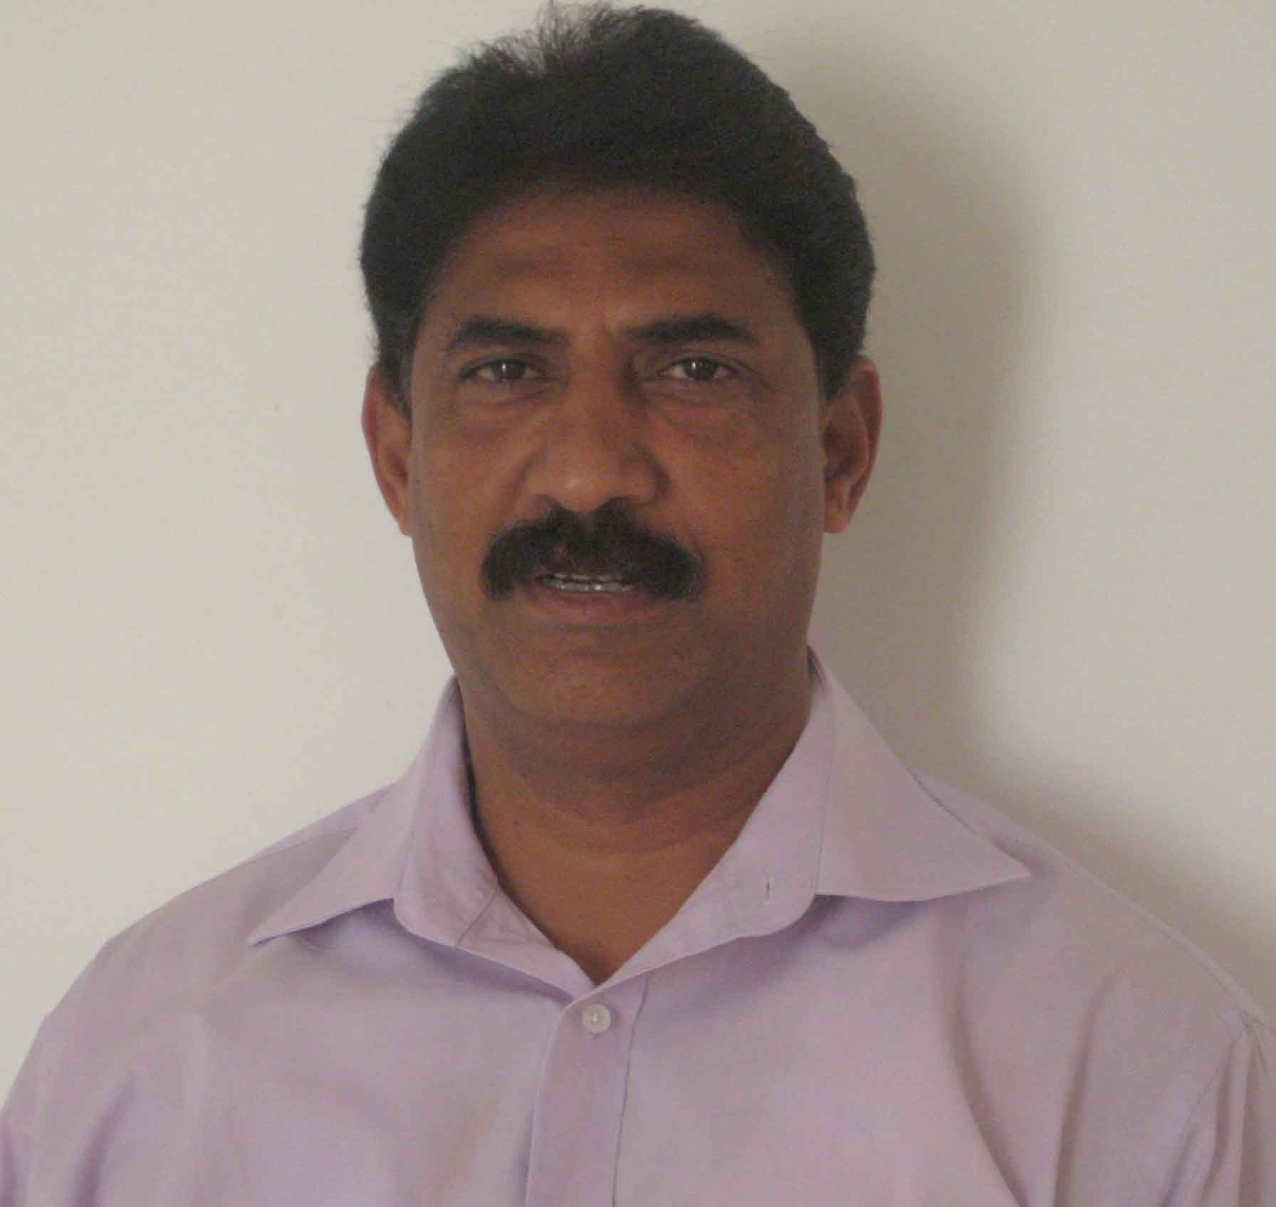
PERSONAL DETAILS

Name : Sharad Narayan Manglourkar (SHETTY)
Date of Birth : 24th October 1965
Mobile no : +971 586709003
Email Address : sharadnm@rediffmail.com
Nationality : Indian
Marital Status : Married
Gender : Male
Passport No. : U0662499
Language : English, Hindi & Marathi (Written/Spoken &Read)
UAE Driving License : 174119 valid till 10.11.2025

CAREER OBJECTIVES

To pursue a job that offers rewarding challenge and unlimited opportunities for growth and that makes a lasting contribution to my organization through my skills, experience and hard work.

PROFILE

I am an energetic man with go-ahead attitude having great communication skills, required minimal supervision to improve myself with organization goals.

KEY ABILITIES

- Excellent interpersonal skills.
- Excellent communication skills.
- Self-motivated, organized and Results Oriented.
- Excellent in understanding people’s attitude and interest.
- Ability to learn and adapt new skills and procedures quickly.
- Disciplined and enthusiastic working ethics.
- Quick learner and Dedicated to job.
- Numerical Accuracy
- Technological Savvy

WORK EXPERIENCE

BIN FADEL Constructio, ABU DHABI, U A E
Camp Boss/Transport Supervisor from Sept 2006 – Dec 2011

AL KHAYYAT CONTRACTING AND YRADING CO, QATAR, DOHA
Camp Boss / Transport Supervisor from July 2012 to May 2013

Young Hwa ENGINEERING AND STEEL COMPANY, RAS AL KHAIMAH, UAE
Camp Boss / Transport Supervisor from June 2013 to June 2016

DULSCO Manpower Supply, Ras Al Khaimah, UAE
Camp Boss / Transport Supervisor from July 2016 to May 2017.

UTICO FZC, RAS AL KHAIMAH, UAE
Transport Supervisor from July 2017 Till Date

JOB DISCRIPTION

Transport & Logistic Activities:

- Vehicle Renewals and Passing’s. RTA related all works
- Maintaining fleet Charts.
- Invoice distribution and collection of cheque
- Vehicle maintenance and periodical servicing to avoid break downs
- Driver Schedule.
- Petty Cash handling for drivers
- Maintains good relation with rental companies for hiring of vehicles as for the company requirement
- Arranging the pickup and drop of the employees as for schedule time to reach on time for duty.
- Maintains the database of annual vacations of drivers and employees.
- Airport service for the employees pickup and drop for their annual vacation and emergency
- Briefing of driver on weekly basis.
- Daily check list of the vehicles
- Maintains the petrol cards and petrol expenses
- Arranging laborers for medical test for new arrivals and visa renewal
- Handling passport renewal, medical other HR Activities
- Coordinating with the sites on regular basis
- Acting promptly on serious issue like accidents and sickness in labor camp.
- Maintenance of records for kilometer readings
- Maintaining coordination between logistic Department and customers.
- Handle customer problems.

Camp Activities

- Responsible for entire administration of Labor camps of 4500+ Labor – comprises of total 5 blocks & 3 labor camps.
- Supervising the camp staffs including camp boss, clerks, maintenance team, security, cleaners & kitchen staffs.
- Prepare and conduct safety & health trainings for camp staffs.
- Assign staff activity and other responsibilities.
- Supervising the catering operation.
- Monitoring the cleanliness of the camp, Kitchen and Rooms and ensuring proper hygiene according to the Dubai Municipality Regulations to avoid fines.
- Effective maintaining the camp as well through daily check list activities.
- Keeping camp as per SHE policy and DM rules and regulations.
- Ensure asset & stock control
- Preparing requisitions and coordinating with Purchase department / suppliers.
- Allocation of new arrivals to the sites in liaise with HR Department.
- Supervision of central store for accommodation belongings, PPE & Maintenance items for all the labor camps, with proper inventory.
- Monitoring the daily absenteeism and preparing time sheet.
- Arranging laborers for medical test for new arrivals and visa renewal then distribute their work permits and health card with acknowledgement.
- Handling passport renewal, medical other HR Activities
- Coordinating with the sites on regular basis
- Acting promptly on serious issue like accidents and sickness in labor camp.
- Receiving and screening incoming emails, mails and telephones
- Providing secretarial service like, preparing office correspondence, reports and meeting minutes.
- Preparation of MIS Reports and presentations
- Coordinate with Sites / Management to employee related issues

Organization : Bindras Catering and Event services
Designation : Event Organizer
Period : 2OO3 to 2006

Duties and Responsibilities

- Daily Vouching and posting Bank Reconciliations
- Managing Receivables / Payables and Prepare Reports,
- Preparation of Stock Reports & Final Accounts
- Handle Business Correspondence
- Staff Appraisal, Conduct Meetings and keep Minutes
- Conduct Exit Interview, Develop Strategic Plans
- Make Staff Contracts & Business Correspondence
- Daily smooth operation of food and beverage department
- Make telephone calls to potential Customers

Organization : Span group of Hotel (Bombay)
Designation : Trainee Magement
Period : 1983 to 1995

Organization : O N G C (Off Shore)
Designation : Camp Boss
Period : 1995 to 2003

Academic Qualification

Bachelor of Commerce (Business Administration)
Pune University, India.

