

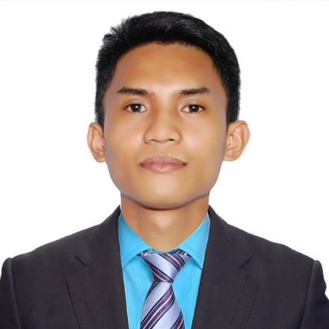

BACHELOR OF SCIENCE MAJOR IN COMPUTER ENGINEERING

University of Perpetual Help System Laguna Isabela Campus

2013-2020

COMPUTER SYSTEM SERVICING (CSS)

March 30, 2017

Strong Work Ethics

Working Well Under Pressure Time Management Abilities Problem-Solving Skills Positive Attitude

Highly Organized

Creativity

Active Listener

Keen to attention detail

CLAIRE G. FRANCISCO, MD

Municipal Health Officer

Phone: 639178001635

Email: [mholuna@yahoo.com.ph](mailto:mholuna@yahoo.com.ph)

KAHREN P. JUSTO, RSW, MSSW DOH-

Development Management Officer IV

Phone: 639175899939

Email: [kahren.justo@gmail.com](mailto:kahren.justo@gmail.com)



 +971569643958 [romnickmatias83@gmail.com](mailto:romnickmatias83@gmail.com) King Faisal, Sharjah, UAE



To work in a dynamic professional environment with a growing organization and utilize my creativity and innovative thinking for the benefit of the organization and myself.



# IT SYSTEM ADMINISTRATOR

RHU-Luna, Isabela - October 2020 – July 2023

Manage data of Vaccine Information Management System / DICT Vaccine Administration System

Responsible on encoding and uploading in system the names of Covid 19 Vaccinees,

and ensured that the Covid 19 Vaccinees are reported.

VAXCert-PH System focal person and assisted on generating the Vaccination Certificate of Vaccinated Individuals.

Securely keeping and maintaining the records of every patient

Responsible for configuring system IT Server and Client Administration running Windows 7 and up

Assigned in installing Operating System and Software Applications

Ensure customer satisfaction and provide professional customer support Maintain a positive, empathetic and professional attitude toward customer at all

times, Build sustainable relationships and trust.

Responsible for preparing printed Reports

# COMPUTER AND CCTV TECHNICIAN

LGU Luna, Isabela - May 2017- October 2020

Responsible for installation and replacement of defective devices and wires

Responsible for monitoring equipment and failures of network connectivity Responsible of Troubleshooting devices (television, monitors, antennas and

input devices)

Responsible for Backed up data and Review CCTV Footage Maintained and updated Windows Operating System

Responsible for resolving functions in software and hardware devices (modems, printers and scanners)

Resolved computer system problems as required Repair and installing network cables



Oriented in Microsoft Office Application (Microsoft Word, Excel and PowerPoint) Knowledge in installing operating systems and application software

Proficient at hardware configuration and Expert in System Assembly Expert at upgrading and repairing computers

Knowledge in Computer Troubleshooting (hardware’s, network, input/ output devices

Network Configuration, Network Troubleshooting, Network Cabling Knowledgeable in Adobe (Photoshop, Premiere Pro)- Graphics Designing Reliable for completing projects on time and accurately