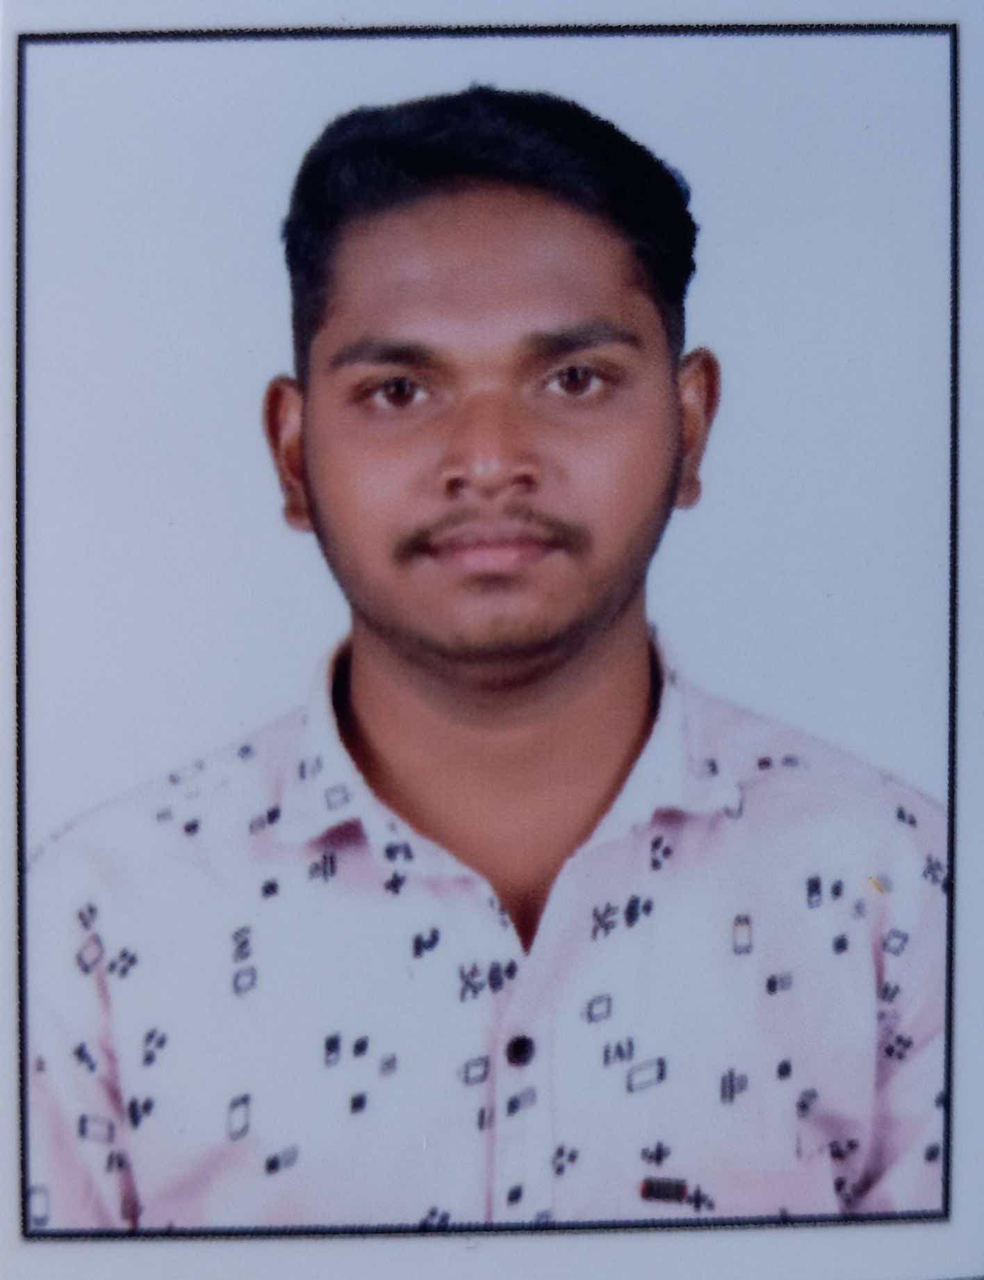 |  |  |  | SANMESH ASHOK KAMBLE

Experience
1 year experience as store keeper in big bazar india
1 year experience as office assistanat in bio restore india pvt.ltd. pune
2 year experience as delivery boy and cash counter staff in dubai.

Education
Bacholar of Art’s, Maharashtra (kolhapur)
- 70.25/%

Communication
Engilsh
Hindi
Marathi
Computer skills
Ms-office, Ms-Word, Ms-Excel

Leadership
To work globally and compitative Environment with a prestigious on challenging assignment that shall yield the twin benefits of the job satisfaction and steady professional growth.

Deceleration
To Information given above true and best to my knowledge if any mistake In it will be sole responsibility if myself only.
At.Manwad Post-Pisatri
Tal-Panhala Dist-Kolhapur
 |  | +971542427880
 |  | Sanmeshkamble2286@gmail.com
Whatsapp No.
+971542427880

