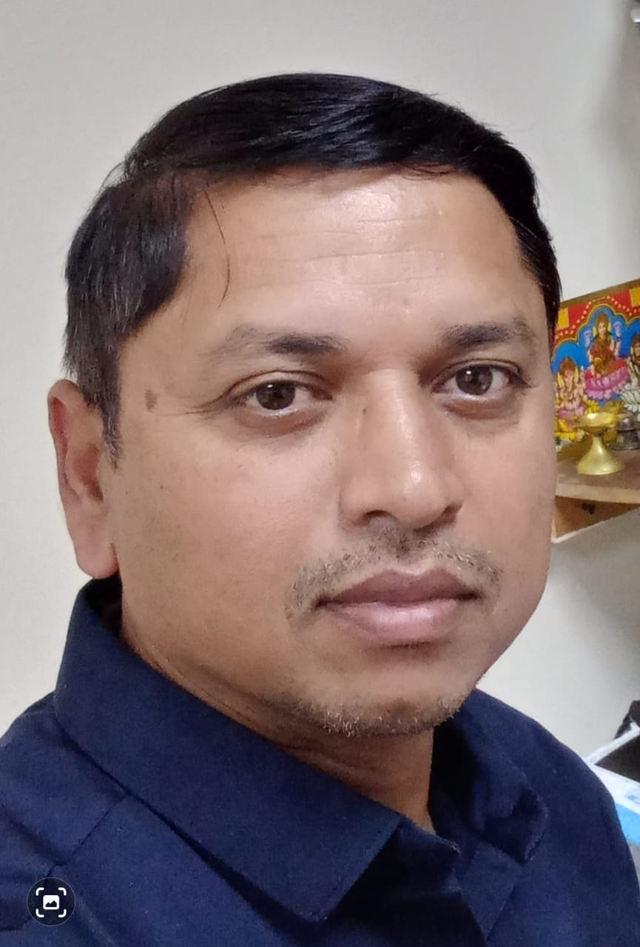

**DEVENDRA M RAVAT**

FLAT No 101 Zainal Building

Near Dubai Museum Bur Dubai

DUBAI, UNITED ARAB EMIRATES

(M) # +971559018338 / +91 9929394631

Email : [devmravat@gmail.com](mailto:devmravat@gmail.com)

*To secure a unique opportunity in well established Organization, where I can utilize my experience and skill of Knowledge and serve the company better.*

**WORK HISTORY**

**1. Sales Co-ordinator – Mausam Foodstuff Mills & Packaging Industries LLC Dubai UAE Since** -**Jan’ 2017 to still working.**(Trading and Import Export of Foodstuff Pulses, Spice, Rice, Sugar, Tomato Paste and HoReCa Items, Sparkling Water Manufacture of Rose Water & Vinegar )

**2. Accountant – Prateek General Trading LLC Dubai UAE Since** -**Feb’ 2015 to Nov 2016.** Company is Trading and Import Export of Rice, Sugar, Pulses

**2. Accountant – Supreme Plastics Industries LLC Dubai UAE Since** -**April’ 2011 to Oct 2014.** Company is manufacturing Plastic CAN Bottle for Oil and Food Industries.

Currently using company Software program and I have good knowledge of Tally ERP software

* Coordinate sales team by managing schedules, filing important documents and communicating relevant information
* Good Knowledge of Export documentation and requirement
* Respond to complaints from customers and give after-sales support when requested
* Store and sort financial and non-financial data in electronic form and present reports
* Handle the processing of all orders with accuracy and timeliness
* Inform clients of unforeseen delays or problems
* Monitor the team’s progress, identify shortcomings and propose improvements
* Assist in the preparation and organizing of promotional material or events

# EDUCATIONAL QUALIFICATION :

Graduation in **Commerce (B.Com)** with Accounts & Auditing subject From The Maharaja Sayajirao University of Baroda Gujarat India.

# PROFESSIONAL QUALIFICATION :

Very Good Command over **MS Excel, MS Word, Power Point and Email**.

Basic Knowledge of HARDWARE AND NETWORKING

Accounting SAP & Tally ERP 9 programme, TALLY ERP LATEST EXCISE & VAT VERSION.

**PERSONAL DETAILS**

**Birth Date**  : 5th September 1980

**Marital Status** : Married

**Language Known** : Gujarati / Hindi /English

**Nationality** : Indian

**Passport No.** : S8779176 Issue from Dubai UAE Exp. Dt 10/10/2030

**Visa Status :** Visit Visa Till 07/06/2024

**FAMILY DETAILS**

**Father Name :** Late Shri Manshankar Ravat

**Mother Name :** Rupaben Ravat (Housewife)

**Spouse Name :** Shina Ravat ( Housewife)

**Child Two**  **:** Daughter & Son

# Declaration

*I hereby declare that the above mentioned information is true to the best of my knowledge. I will try my level best to put all work and effort for the well-being of the enterprise. I am disciplined and well adaptable to any of the situations.*