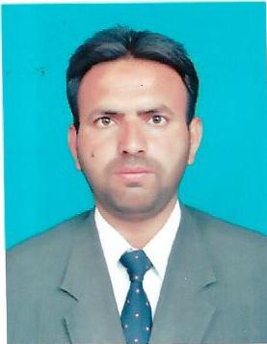**MUHAMMAD INAM BARI**

**🗐 OBJECTIVE:**

To work with devotion, discipline and determination in the growing environment of the organization in order to polish my skills and give maximum benefit to the organization and nation.

**🗐 Area of Intrest:**

* Store Department.

**🗐 PERSONAL INFORMATION:**

Father Name: Abdul Ghafoor

CNIC #: 35103-8620404-1

Address: Near Education office Model Town Pattoki District Kasur.

Cell #: 0302-9528411-0331-4192184

E-Mail Address inambary@gmail.com

Domicile: Kasur (Punjab)

Nationality: Pakistani

D.O.B: 27/01/1982

Marital Status: Married

**🗐 ACADEMIC QUALIFICATION:**

1. Matric from Lahore Board

2. D.Com From Technical Board Lahore

**🗐 Computer Skill:**

1. Office Management

**🗐 PROFESSIONAL EXPERIENCE:**

1. Worked as a Assistant Store Incharge cum Purchase Officer in Paradise Spinning Mills (PVT) LTD from 19-12-2004 To 10-07-2007
2. Worked as a Admin Officer in Orient Electronic (PVT) LTD from 01 Year
3. Worked as a Assistant Store Keeper in TriTex Cotton Mills (PVT) LTD from 07-07-2008 To 08-07-2010
4. Worked as a Gate Incharge in Ali Akbar Spinning Mills (PVT) LTD from 01 Year
5. Worked as a Excise and Cotton Incharge in Basfa Textile Mills (PVT) LTD from 20-10-2011 To 10-11-2013 and 20-01-2015 To 01-04-2017
6. Worked as a Excise Incharge in Resham Textile Mills (PVT) LTD from 25-11-2013 To 15-01-2015
7. Worked as a Store Incharge in Resham Textile Mills (PVT) LTD for Continue and 7 year (2017 - 2024)

**🗐 EXTRA CURRICULUM ACTIVITIES:**

1. Sport like, Foot Ball , Reading Newspaper & study the religious & other Books