***DILAWAR SINGH SHEKHAWAT*** 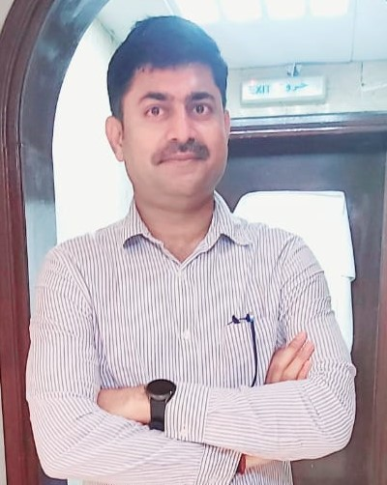

***Post applied: - Assistant Store Manager***

*: +****971-564096176, 8107002386***

*****: Dilawar.shekh0011@gmail.com***

# OBJECTIVE

To work in organization where I can gain knowledge and skill, through which I can contribute to the development of the organization and achieve, set goals.

# PROFILE SUMMARY

I am a well-organized individual used to working under pressure and delivering to Deadlines. A team player who is able to manage self independently and effectively and driven by a desire to succeed.

# WORK EXPERIENCE

**Storekeeper at United Iron & Steel Company LLC, Abu Dhabi- UAE, Duration: Jan 2021 to present.**

**Responsibilities**:

* To receive the material as per purchase order/delivery schedule
* Perform other stock-related duties, including returning, packing, pricing, and labelling supplies
* All documents are sent to stores for verification. Store executive verifies the presence of relevant document i. e., invoice/challan copy, and excise moderate copy. Stores also verify that material is received against purchase order or delivery schedule.
* *Maintain receipts, records, and withdrawals of the stockroom.*
* *Perform other stock-related duties, including returning, packing, pricing, and labelling supplies*
* *Inspect deliveries for damage or discrepancies; report those to accounting for reimbursements and record keeping*

**Store Executive at RSWM Ltd, Bhilwara – Rajasthan, India. Duration: July 2019 to Dec-2020**

**Responsibilities**:

* *Maintain receipts, records, and withdrawals of the stockroom*
* *Perform other stock-related duties, including returning, packing, pricing, and labelling supplies*
* *Inspect deliveries for damage or discrepancies; report those to accounting for reimbursements and record keeping*
* *Rotate stock and coordinate the disposal of surpluses*
* *Ensure adequate record keeping and manage all documentation to confirm proper stock levels and maintain inventory control*
* *Coordinate the handling of freight, the movement of equipment, and necessary minor repairs. Accepted material is transfer to main store and rejected material in rejection Area.*
* *All rejections are intimated to purchase in Rejection / Rectification Note by QC/User. Accepted material quantity is fed to the System.*

**Storekeeper / Dispatcher at METENERE LIMITED at Gujrat India. Duration: April 2018 to May 2019**

**Responsibilities**:

* Perform other stock-related duties, including returning, packing, pricing, and labelling supplies
* All documents are sent to stores for verification. Store executive verifies the presence of relevant document i. e., invoice/challan copy, and excise moderate copy. Stores also verify that material is received against purchase order or delivery schedule.

The stores section identifies the material with Yellow Tag (FMT/STR/002). Accepted material is transfer to main store and rejected material in rejection Area.

**Store Executive at Asian Colour Coated Ispat Ltd, Khapoli – Mumbai, India. Duration: March 2015 to Feb 2016**

**Responsibilities**:

* *Maintain receipts, records, and withdrawals of the stockroom.*
* *Perform other stock-related duties, including returning, packing, pricing, and labelling supplies*
* *Inspect deliveries for damage or discrepancies; report those to accounting for reimbursements and record keeping*
* *Rotate stock and coordinate the disposal of surpluses*

**Grand Technical Trading Co. LLC, Abu Dhabi – United Arab Emirates Duration: Feb’2012 to Jan- 2015 and Apr 2016 to Jan-2018 as Store- Assistant,**

**Responsibilities**:

* *Responsible for All Consumables Material Inward Entry in SAP/Tally*
* *Quantity Verification of Inward Material as Per Po and Party's Delivery Challan.*
* *Responsible for Material Verification as per Specification*
* *To Check Material for Quality and Damages*
* *Responsible for Getting Material Checked from the USER*
* *To Inform Quality Department and Purchase Department after Receipt of Product*
* *To Issue Material to the Concerned Department/User*
* *To Prepare Monthly Store Inventory Report*

**EDUCATION**

**GRADUATION (Bachelor of Commerce)**

I have done Graduation from Din Dayal Upadhyay University, Gorakhpur, UP. In faculty of Commerce. Major subjects of study were Accounts, Banking and Business Administration.

**OTHER COMPETENCIES AND SKILLS**

Languages Hindi – Native Speaker

English – Intermediate level, conversationally fluent

Computer Operating System: Window 98/2000/XP/ Window 8/ Windows 10/ Mac Typing Up to 30 Words per Minute.

Tools Microsoft office Tools, Excel, PowerPoint, MS-word, Photoshop, All web

browsers and Internet expert user.

Soft skills Adept at being flexible and multitasking, managing various activities at the same time.

Creative and optimistic in approach.

Ability to immediately respond to changing situations. Perform operations/services as required under instruction. Ability to work under pressure.

Perform operation in varying conditions.

**PERSONAL DETAILS**

|  |  |  |
| --- | --- | --- |
| Date of Birth: | : | 7-July -1988 |
| Father’s Name | : | Nandu Singh Shekhawat |
| Marital Status | : | Married |
| Passport Number | : | U-7150108 / Expiry: 19-February-2030 |
| Nationality: | : | Indian |
| Address | : | VPO- Jhajhar, P.S -.Nawalgarh, Dist.–Jhunjhunu, Rajasthan (IND) 333304 |