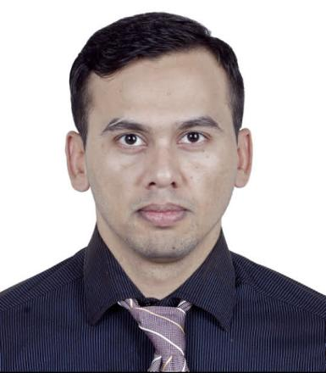

EDUCATION

2013 To 2015

**Punjab College of Commerce**

Intermediate in commerce

Major in Accounting,Banking,Economics and Business Math

2011 To 2013

**Govt.High School**

Matriculation

Major in Mathematics,Physics,Chemistry and Biology

Me

About me

I’m familiar to related regulations and institutions, thus able to control the risk of hospitality services.

Consequently my positive attitude and strong ability of learning led to my academic achievement.

Possesses excellent organizational and multitasking skills and provides excellent customer service. Last but not least, I’m always honest by sticking to my promise and always willing to communicate with others or to help them with a great sense of teamwork.

**Wahab Ijaz**

Phone +971-56-4304151

Email wahabijaz11@gmail.com

AddressDIP2,Ritaj K Block,Dubai

certificate

* MS Office
* MS Word
* MS Excel
* Powerpoint
* Graphic Design

2021 To 2022

**Season Four Hotel**

Front desk Agent

* Provides entry level accounting services including entering .cash receipts,balancing cash drawers, credit card and to check cash registers.
* Abiding the regulations and working closely with the operating administration and other co-workers.

Professional

* Familiar to counter business and able to operate counter business independently..
* Skilled in cash counting and bill printing.
* Abilities in English and logical thinking and strong sense of teamwork.

Work experience

2019 To 2021

**Javson Hotel**

Night Auditor+Front desk Agent

* Supervise front desk operations to ensure that all guests received superior customer services from hotel employee.
* Investigate auditing discrepancies.by reconciling cash drop and credit card transactions.

2022 Till Date

**Marina Hotel Apartment**

Room Attendant

* Providing customer with excellent cleaning service.
* Making beds doing vaccum and mopping on floor and make the room fresh ready. .