Curriculum Vitae
Heavy Bus Driver, Office Work

Objective
Seekinga position in heavy Bus driver with an organization,Which would make full use of the knowledge and skills I have acquired through theyears.
Personal Information

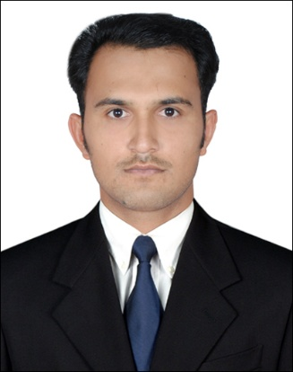

Name: Muhammad Saleh
S / O: Noor–ul-Hassan
Date of Birth: 14, Aug 1986
Religion: Islam
Nationality: Pakistan
Marital: Married
Languages Known: Urdu, Panjabi,
Phone: +971 554136329 +92 3005459026
Email: salehnujmi26@gmail.com

Education, Qualification

Metric / ICS / (FA)
Microsoft Office Management (Word,Exel) Diploma. Vehicle Mechanical Theory Diploma.

Work Experience

From 2005 to 2007. Work in Time office Pakistan
From Jan 2008 to Jan 2011. Heavy Duty Driver in Pakistan…

From April,2012 to Feb,2016 Heavy Bus Driver In El Saif
Engineering cont, Abu Dhabi Dubai.

From 2017 to March, 2019. Heavy Bus Driver,In DulscoLLC, Dubai.

From Jan,2019 to Aprl, 2019 Heavy Bus Drive, Descon engineering.
With Barouj oil Company.
From Nov,2020 to till. Heavy Bus driver in Emrill Services
LLC, Dubai.

No any traffic Fine in UAE all Driving period.
License Details,
License no, 2053388
Type of License. Heavy Bus
Date of Issue, 09, Apr-2012
Date of Expire 07-Mar-2027

