**NISHIL A**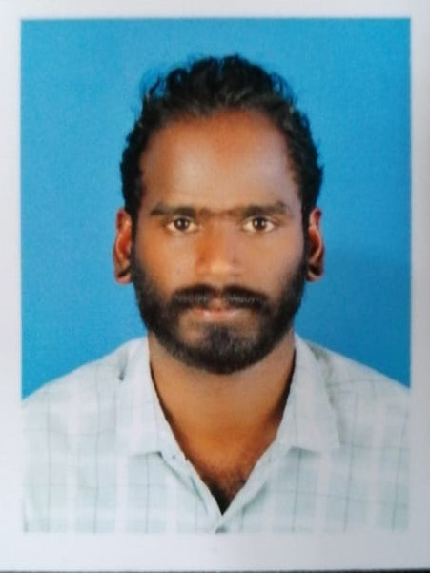

# Contact

**Address: -** Photocopy Building, Room No 207,Near Fish Roundabout, Deira, Dubai

**Phone: -+971 583078775, +91 9895157939(whatsup)** **Email:-**[nishilarambannishilaramban@gmail.com](mailto:nishilarambannishilaramban@gmail.com)

# Skills

* Inventory management
* Ability to cope with the different situations.
* Self-Motivated
* Dedicated Team Player
* B 2 B Sales
* Customer and Client relations.
* Observation
* Painting
* Leadership

# Languages

* English
* Hindi
* Malayalam (M)
* Tamil

# Hobbies

* Sports Activities,
* Travelling
* Browsing

# Personal Details

**Date Of Birth:-** 24-04-1989

**Marital Status:-** Single

**Passport No:-** S3139300

**Visa Status :-** Visit Visa (Till 21-03-2023)

# 

# Professional Summary

# A motivated salesman with 12 years of experience in customer service and sales. Skilled in providing friendly and professional customer interactions, as well as up-to-date product knowledge to maximize sales potential. Proven track record of answering customer questions and increasing customer satisfaction.

# Experience

* 1. **Sales Representative at Thanuja Enterprises January 2020 to December 2023**
* Maintained up-to-date knowledge of available products to best serve customers and maximize sales potential.
* Answered customer’s questions regarding products, prices and availability.
* Managed friendly and professional customer interactions.
* Identify customer needs and make appropriate recommendations.
  1. **Sales in charge at Drops Ready-mades - November 2018 to July 2019.**
* Guided and recommended the clothes to customers matching with their personality.
* Selected dresses as per customers choice and preference and convinced them for a trial.
* Operated computerized sales tracking systems and updated sales transactions.
* Receiving and stocking the merchandise. Inventory and secure merchandise at the close of business.
  1. **Salesman at Mengo Gents ready-mades - January 2016 to June 2018**
* Answer customer’s questions about clothes like brand, matching colors etc.
* Greet and direct customers.
* Ensure racks are properly arranges with attractive readymade dress.
* Manage returns of readymade clothes.
  1. **Salesman for Gents and Boys Section at Al Manama Silks - April 2011 to November 2015**
* Worked closely with sales representatives and assisted in any duties as assigned by managers.
* Guided and recommended the clothes to customers matching with their personality.
* Assisted in inventory management and pro-actively participated in weekly team meetings with managers.

# Education

* SSLC: Kerala state Board 2004
* Pluse Two: Kerala state Board 2006

# Additional Qualification

* Microsoft Office
* Certified Data Entry and Office Automations

# Declaration

I **Nishil** hereby declares that all the above information furnished by me, is true best of my knowledge and brief.

**NISHIL A**