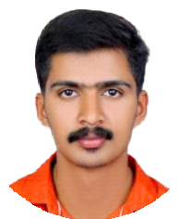

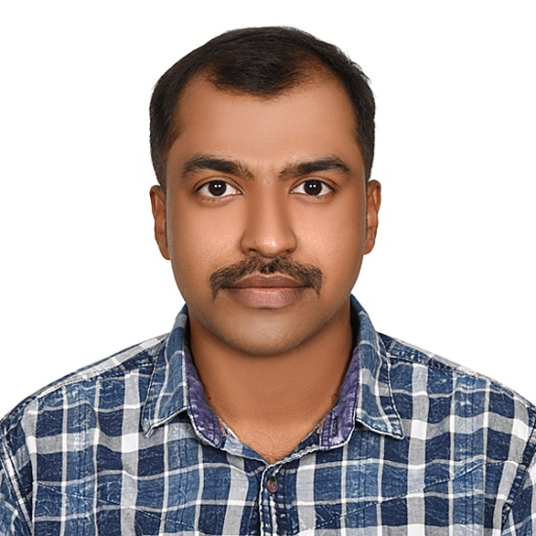RAMITH K P

SALES EXECUTIVE

To be a part of a reputed and progressive organization in order to gain knowledge and assist the professionals in performance of their duties and Responsibilities for achieving their goals and objectives efficiently and effectively,

**EMPLOYMENT**

# SALES EXECUTIVE (LUBE)

ADNOC DISTRIBUTION, ABUDHABI (Jun 2021 - May 2023)

* Checking vehicle fluids such as engine oil, brake fluid, power oil and antifreeze
* Monitoring product inventory by tracking stock items with advanced skills in MS Excel.
* Preparing daily and monthly sales report by using MS Excel.
* Troubleshoot vehicle computer system with OBD machine
* Selling of products like injectors, protectors, blades and filters.
* Developed new client relationships and expanded existing accounts, resulting increase in revenue

# FUEL SALES ATTENDANT

ADNOC DISTRIBUTION, ABUDHABI (Jan 2016 - Jun 2021)

* Greeting customers when they approach the station

and asking if they need assistance with anything provided by the store.

* Solving customer complaints and make them happy.

**PERSONAL DETAILS**

Date of Birth 15-Feb-1990

Nationality Indian

Relationship Married

Sex Male

Father Name Ramesh Religion Hindu

**CONTACT DETAILS**

* Selling products like injectors and convincing about new offer.

Mobile Whatsapp

+971 568857145

+971 568857145

# SALES EXECUTIVE

HARISREE BROADBAND PVT LTD, KERALA (Feb 2012 - Jan 2015)

* Develop and implement effective sales strategies to promote and networking equipment to IT professionals, firms, colleges, and other business facilities.
* Configure and installing of new networking devices at client site and ensure secure connection.
* Conduct product presentations and demonstrations to showcase the features of new networking devices.
* Negotiate pricing, contracts, and terms of sale to secure new business and maintain customer satisfaction.

E-mail ramithsrb@gmail,com

Address (UAE) Karama, Dubai,

United Arab Emirates

Address (IND) “Sushama” Po temple gate

Kannur, Kerala, India

**LANGUAGES**

**EDUCATION**

BACHELOR OF COMPUTER APPLICATION (BCA)

English Hindi Malayalam

Arabic

Read, Write, Speak Read, Write, Speak Read, Write, Speak Speak

Madurai kamaraj university, Madurai,

India (2014)

HIGHER SECONDARY EDUCATION - SCIENCE

PALAYAD Higher Secondary School, Palayad, Kannur Dt, Kerala, India

**PASSPORT DETAILS**

Passport No U0730389 Date of Issue 25-Feb-2021 Date of Expiry 24-Feb-2031 Place of Issue Abudhabi

**KEY SKILLS**

Competent knowledge in Ms office Excel, Word and Outlook mail Windows 7/8/8.1/10/11

Internet browsing and emailing, Software installation

Driving (Light Vehicle Manual Gear)

Multi linguistic skills (English, Arabic and Hindi

Flexible work timings

**DRIVING LICENSE DETAILS**

License No 2412399

Place of Issue Abu Dhabi

License Type Light Vehicle Manual

**VISA DETAILS**

Visa Status Resident Visa