**CURRICULUM VITAE**

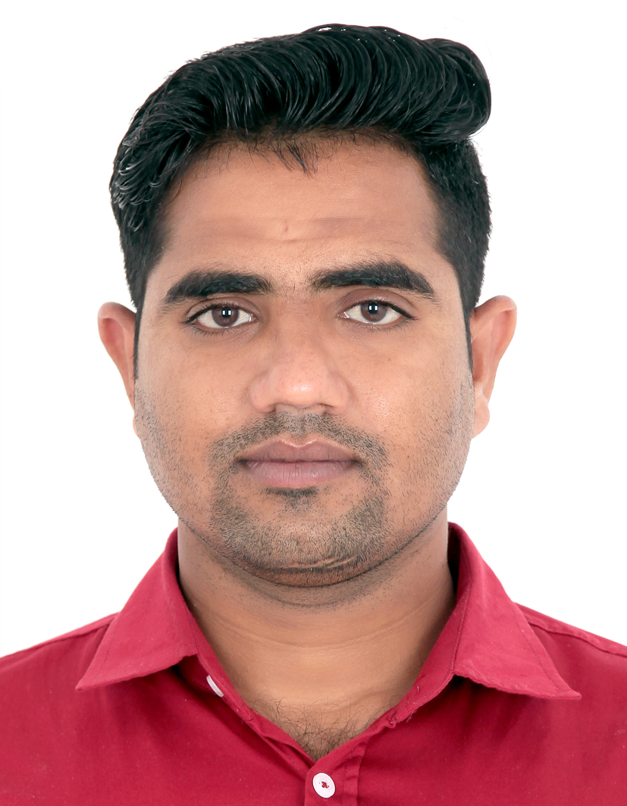

**VINOD KUMAR JANGIR**

Dubai, UAE

Contact No: +971564589649

E-mail: jangirv747@gmail.com

|  |
| --- |
| **OBJECTIVE** |

Obtain a career with an organization providing career growth based on the performance and accomplishment where I can apply my acquired skills and abilities that enable me to contribute to the company goals.

|  |
| --- |
| **STRENGTHS** |

* To work in challenging and productive environment, where I am able to deliver the best my ability and satisfaction.
* Willing to take up responsibilities, to share and contribute the knowledge and experience gained, and learn through pro-active participation.
* Capable of taking on totally diverse function to meet the company’s goal.

|  |
| --- |
| **PROFESSIONAL EXPERIENCE** |

6 Years experience as a ASSITANT MANAGER at WEST ZONE SUPER MARKET Dubai

UAE ( FROM 13 NOV 2017 TO TILL DATE )

|  |
| --- |
| **KEY AND RESPONSIBILITY AREAS** |

* Greet the customer entering in the store.
* Assist the customer what they need.
* Count money in the cash drawer at the beginning of the shifts to ensure that the amount are correct and that there is adequate change.
* Received payment by cash or credit.
* Resolved customer complaints.
* Answers customer’s questions and provide information on procedures or policies.
* Established or identify price of good services or admission and tabulate bills using calculators, cash registers or optical price scanner.

|  |
| --- |
| **EDUCATIONAL QUALIFICATION** |

* B.A. from Maharaja ganga singh university Bikaner Rajasthan

|  |
| --- |
| **COMPUTER QUALIFICATION** |

* MS Office (Word, Excel & PowerPoint)
* Internet

|  |
| --- |
| **PERSONAL INFORMATION** |

Name : VINOD KUMAR JANGIR

Date of Birth : 13/10/1995

Nationality : Indian

Gender : MALE

Marital Status : single

Language known : English, Hindi

Visa status : EMPLOYMENT VISA

|  |
| --- |
| **DECLEARATION** |

It is endeavour that I would like to contribute my efforts and enclose here above my detailed CV for your kind perusal and consideration. Giving an opportunity, I am optimist that a synergetic could be established.

**VINOD K. JANGIR**