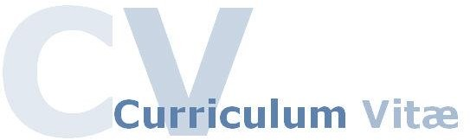



# 

# IBEH M ESOMONU

Address: Qadri Masjid Al Sataw Dubai UAE

Mobile: +971 58 856 8917

Email: esomonu86@gmail.com

**POST:**

**WAREHOUSE ASSISTANT**

CAREER OBJECTIVES

To be able to work in a company where I could apply my acquired knowledge from my previous work experience and to contribute most especially to the company’s interest

WORK EXPERIENCE

**Marketing Head - [09/2011 to 02/2015] Henright Business Concept Enugn Nigeria**

**Store keeper - [05/2015 to 02/2022] Bright Star Technologies Ltd Lagos Nigeria**

**Nursing Assistant - [05/2022 to 10/2022] GSM Medical Center LLC**

Duties & RESPONSIBILITIES

**Take delivery of all incoming materials and reconcile with purchase orders**

**Track, document, and resolve any discrepancies on received orders**

**Ensure accuracy of the facility’s inventory system by updating records of physical inventory totals, receipts, adjustments, and returns**

**Manage inventory/supplies and ensure they are within the established minimum and maximum levels**

**Keep up-to-date records of receipts, records, and withdrawals from the stockroom**

**Responsible for packing, pricing, labeling, and returning supplies**

**Responsible for stock rotation and coordinate the disposal of surpluses**

**Oversee the handling of freight, the movement of equipment, and minor repairs**

**Manage supplier relations and database as well as maintain high ethical relationships both internally and externally**

**Create purchase orders and utilize purchasing card to perform low-value procurement activities**

**Responsible for shipping cancelled or damaged items back to suppliers as appropriate.**

SKILLS & KEY COMPETENCIES

* Having a friendly & professional manner.
* Calm, efficient and organized.
* Friendly disposition with clear spoken English.
* The motivation to learn new knowledge and skills
* Hard working self-motivated team player.

EDUCATIONAL BACKGROUND

Diploma Marketing - [09/2007] Brilliant Academy Lagos Nigeria

Certified Nursing Assistant - [2022] Strong points education training institute - Dubai UAE

PERSONAL PROFILE

Date of Birth : 15/05/1986

Nationality : Nigerian

Gender : Male

Religion : Christianity

Marital State : Single

Visa Status : Partner Visa

Passport Number : A 12205646

Languages known : English.

DE• CLARATION

I hereby state that the above furnished information is true and accurate to the best of my knowledge and the above mentioned certificates are genuine and declare that if I am appointed I will discharge my duties to the entire satisfaction of my superiors.

# IBEH M ESOMONU