**SABEEB. N**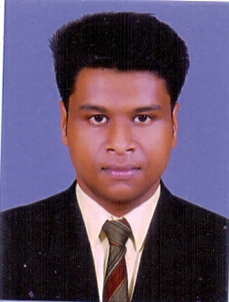

Sabeeb Manzil

MuthiyankuzhiDaivapura P O Thiruvananthapuram

Kerala, India

Pin – 695 563

Mob : +91 95264 07564

Email : [sabeebnoushad@gmail.com](mailto:sabeebnoushad@gmail.com)



**OBJECTIVE**

I want to excel in this field with hard work and dedication.

**EDUCATIIONAL QAUALIFICATION**

* Completed Diploma in Graphics Design and Information Technology (2021)
* Completed a short term course in aviation and ground handling with BIA&L (2019)
* Completed Diploma in Aviation and Airline Management (2019)

* Completed Highter Secondary (2017)
* Completed SSLC (2015)

**STRENGTH AND SUMMARY**

* Hard Working
* Good team player

**HOBBIES**

* Listening to Music
* Travelling

**WORK EXPERIENCE**

* One year sales executive experience in Mahindra first choice
* One year sales promoter in lulu mall trivandrum

**ACHIEVEMENTS**

* NCC

**PERSONAL DETAILS**

Name : Sabeeb. N

Father’s Name : Noushad

Date of Birth : 03-04-1999

Gender : Male

Martial Status : Single

Passport Number : S5180153

Date of Issue : 05/11/2018

Date of expiry : 04/11/2028

Pan card number : LETPS1860Q

Adhaaar number : 379647478981

Nationality : India

**LANGUAGES KNOWN**

* English
* Malayalam

**DECLARATION**

I hereby declare that all the information mentioned above are true and correct to the best of my knowledge and belief.

Place : Trivandum

Date : 07/05/2022 **SABEEB. N**