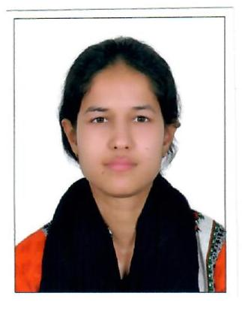*Curriculum Vitae*

Saima Mazhar

Sharjah UAE

MOB: 0589382727

**Career Objectives**

• To pursue a career in a reputable organization, which offers professional environment and opportunities for career development where my attributes/skills can be utilized in various capacities.

• I am young energetic and enthusiastic person ready to accept any challenge looking for excellent career and growth through hard working.

• To work honest and hard for the good name of organization and mutual benefits.

**Competencies**

● Hardworking

● Enthusiastic

• Reliable

• Responsible

**•** Positive Attitude

**Working Experience**

● 5 years as an operation manager in Abraj al Nisr General Trading LLC

(2018 till date)

**Responsibilities:**

1,To keep an eye on daily sales on ecommerce platforms

2, To update inventory on daily sales

3, To arrange stock from market locally or internationally based

4, To organize the stock in Warehouse

5, To make strategy to increase daily sales on ecommerce platforms

6, Handling customers complains and late orders.

7, To follow up with suppliers and market research on new products

• 2 years as a CSR in Digicom Traders (Call center agent)

**Responsibilities**

1, To receive calls on daily bases based on customer issues

2, Resolve their queries, complains

**Responsibilities**

1, To follow up customers orders , late dispatched and complains.

2, To satisfy customer if having any issue or order complain

3, Follow up for refund to customer if order has been cancelled

**Academic Qualification**

• Intermediate : Pre-Medical (Karachi Board)

• Matriculation : Science (Karachi Board)

**Personal Data**

• Father’s Name : Mazhar Ahmed (Late)

• Date of Birth : 11.02.1990

• Religion : Islam

• Martial Status : Married

• Nationality : Pakistani

• Language : Urdu, English

Passport: : FW0844612

**Computer Skills**

My skills are fluent on the following application operation system.

Application : Ms. Word, Ms. Power Point,Ms.excel. Basic Knowledge : Internet, E-mail and office management. Operating System : Window XP,

Knowledge about MS Office, Graphics , Internet Surfing & Browsing

**Reference**

Available on Request.