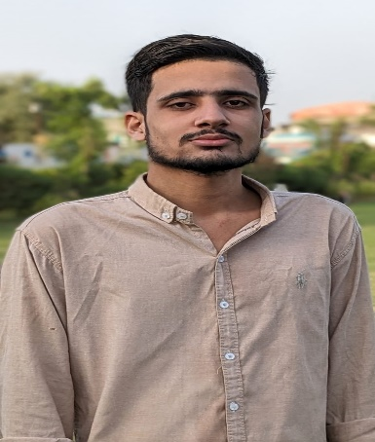RAJA HARIS SHAKEEL

House No. C-295 Yousuf plaza block 16 Khi.

**Cell: +92-318-2477758**

|  |
| --- |
| **OBJECTIVE:** |

To acquire a position in an organization that can provide me an opportunity to face challenges and utilize my professional skills.

|  |
| --- |
| **PERSONAL INFORMATION:** |

* Father’s Name : Raja Shakeel
* Date of Birth : 27-08-2000
* CNIC No. : 42101-4149766-5
* Religion : Islam
* Nationality : Pakistani
* Marital Status : Un-Married

|  |
| --- |
| **QUALIFICATION:** |

* **Matric**

from Board of Secondary Education Karachi

|  |
| --- |
| **WORKING EXPERIENCE:** |

**02 years’ experience in super market as a store keeper**

Responsibilities

* checking sell-by dates and rotating stock
* managing inventory
* organizing and maintaining stock
* maintain the store neat and clean
* keep a record of sales and restock
* Ensuring proper storage of goods following the FIFO method
* Applying FIFO

**3 years’ experience in Broadway pizza as a Delivery assistant**

Responsibilities

Customer services

Delivery food to customers on promise time

Ensure timely and safe deliveries

Report any issue or concern to the supervisor

|  |
| --- |
| **KEY SKILLS** |

Customer services

Team work

Problem solving

|  |
| --- |
| **INTEREST** |

Gaming

Watching movies

Traveling and outdoor activities

|  |
| --- |
| **REFERENCES:** |

* Will be furnished upon request.