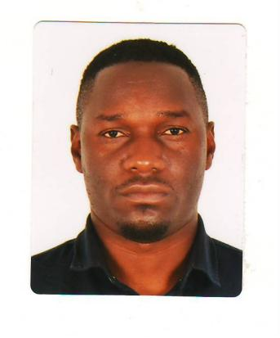
CURRICULUM VITAE

Name: NAMPALA DANNY
Mob: +971543647956

Email: shanevybz@gmail.com

CARRIER OBJECTIVE
To become a developed specialist and scholar in a fast-paced environment within an international institution demanding strong analytic organization, interpersonal and management skills in the area of investments, hospitality, finance.

PERSONAL PROFILE
- Self-motivated
- Highly organized
- integrity
- Goal oriented
- Honest
- Dedicated
- Team builder
- Economically efficient
- Determined and reliable with the drive to be trained and learn quickly

SPECIAL ABILITIES
- High interpersonal skills
- Good communication, work well in levels of management
- Very eloquent public speaker
- Quick learning
- Excellent training ability

PERSONAL QUALITIES
- Good communication and mobilization skills
- Exceptional speaking and listening abilities

WORK EXPERIENCE

ZUNDATI (DSI)
• COMPUTER REPAIR AND MENTENANCE
• SOFTWARE AND DATA ANALYST

LEGACY ELECTRONICS

- Electral installation
- Maintenance of electral equipment
- Industrial electrical services

EDUCATION ATTAINMENT
- Uganda certificate of education :2007
- Uganda advanced certificate of education :2009
- Diploma in industrial art and design :2015

PRSONAL DETAILS

Nationality Ugandan
Date of birth 03-03-1991
Religion Christian
Languages English, Luganda
Marital status Married

