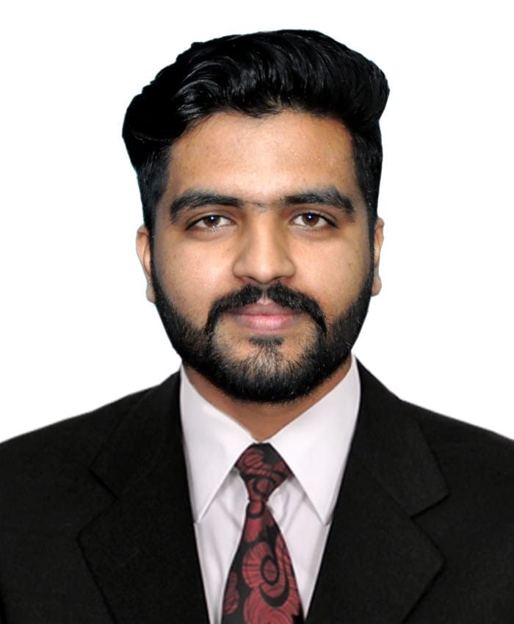 |  | binyamin siddique  Mobile: +97150 989 0860  Email: shansiddique0070@gmail.com  UAE Driving License (Light Vehicle)
Profile  A Dynamic, dedicated and continuously improving in professional skills with proven ability to work and able to achieving the target of completion.  Contact  PHONE:  +971 50 989 0860  EMAIL  shansiddique0070@gmail.com  ADDITIONAL INFORMATION  Date of Birth: 08-Aug-1995  Visa Status: OWN VISA  Language: English, Urdu.  UAE Driving License  Motor Bike  Light Vehicle Driver  activities and interests  Cooking Food  Outdoor games  Traveling |  | WORK EXPERIENCE  Light Vehicle Driver  - With strong depth of knowledge of all Rules & regulations of UAE. Committed to completing my route timely, safely and efficiently with excellent navigation skills and able to accurately read maps of new routes for deliveries. I have a clean driving record and have a solid background in a variety of warehouses and customers.  Work Experience:  - 03 years’ Experience as a sale man in Giga mall Carrefour in Islamabad – Pakistan  - 06 Months’ Experience in Noon Food delivery and courier – Abu Dhabi  - 06 Month work as a Merchandiser in Majestic Super Store.  Duties and Responsibilities  - Completing on-time deliveries using the most efficient routes.  - • Loading vehicle and properly securing items to prevent damage during transportation  - Keeping the vehicle clean and in good working condition  - Cross-sell merchandise and services  - Communication, time management and customer service.  - Interpreting maps and following verbal and written directions.  - Excellent driving skills and ability to perform physically demanding tasks.  - Proficiency in driving long distances.  - Knowledgeable in all roads in the UAE and there timing.  - Make deliveries and pick-ups in a timely manner  EDUCATION  FA Pass – Rawalpindi, PAKISTAN  key skills and characteristics  - Performance and quality  - Leadership and strategy  - Facility information  - Achievements of Targets  - Good Communication with Clients  - Strong interpersonal skills and ability to work in a team  - Follow-up on actions based on various team

