With my exceptional service standards, seamlessly managing multiple tables and ensuring a welcoming atmosphere am looking for an opportunity to utilize my skills and experience in an institution like yours.

# Personal Details

# Date of Birth : 22-10-1995

# Nationality : Kenyan

# Marital Status : Married

# Gender : Female

# Vista Status : Visit Visa Valid.

# Work History

1.Hamra Square

Beirut Lebanon (2019-2023)

2.Hilltop Hotel Keroka, Kenya.

Kenya (2017-2018)

***Roles and Responsibilities***

**Taking Orders**: Listening to customer orders and accurately entering them into the system.

• **Serving Food and Beverages**: Delivering orders to tables and ensuring everything is correct.

• **Providing Recommendations**: Suggesting menu items and answering questions about the menu.

• **Checking on Customers**: Regularly visiting tables to ensure customer satisfaction and refilling drinks.

• **Processing Payments**: Handling cash and credit card transactions and providing change or receipts.

• **Cleaning Tables**: Clearing dishes and preparing tables for new customers.

• **Collaborating with Kitchen Staff**: Communicating any special requests or issues with orders.

• **Adhering to Health and Safety Standards**: Following protocols for food safety and cleanliness.

# Education

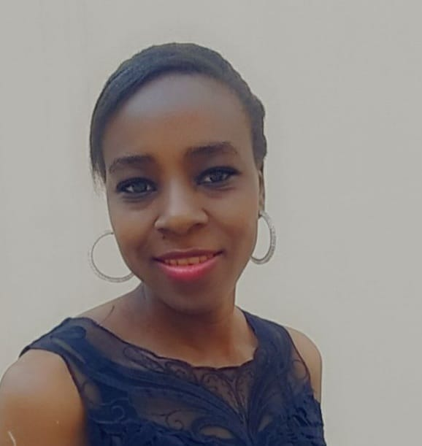

**Damack Momanyi**

Waitress

**Contact**

**Address**

Uae

**Phone**

0503189854

**E-mail**

[Damackmweni@gmail.com](mailto:Damackmweni@gmail.com)

**Skills**

Beverage preparation

Communication skills Dining area maintenance Daily specials memorization Guest relations

management

**Languages**

Arabic

Intermediate (B1)

English

Advanced (C1)

2012-11

## High School Diploma : High School Diploma

*Silanga High School - Kenya*