**DAVID ATEF KAMEL** 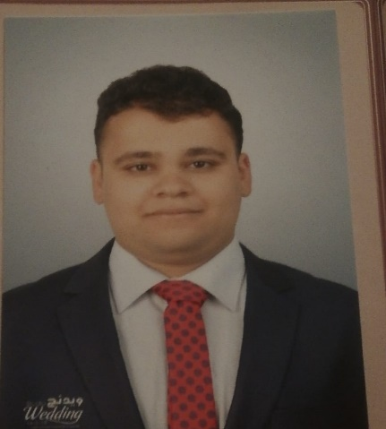

**Nationality**: Egyptian

**Military** **status**: Exempted

**Address : Cairo governorate, Snan street , block number 5**

**Phone**: 01289637980

**Email**: [Dododododavadivo@yahoo.com](mailto:Dododododavadivo@yahoo.com)

**Education**

**ELSALAM private language school (SLS)**

**Faculty of commerce, English section, Credit hour system, Tanta University**

* Bachelor degree in Business Information system , English section
* Graduation project: marketing and electronic marketing
* Overall rating: good
* Graduation year: JUNE, 2021

**Training**

* **BANK BLOM**

Trained as a customer service agent during summer intership from 1st of July 2022 until 1st of August 2022

* **ELSHAHER Automotive for trading cars**

Trained as a data entry agent during summer intership from 1st of July 2020 until 1st of October 2020

**Work Experience**

* **Dual IT**

Customer service

From February 2024 until now

**BANK - ELMASHREQ**

Customer service and call center agent from 31 October 2022 until now

**ORANGE company for telecommunication**

* Customer service and sales agent from 1st of June 2022 until 1st of September

**Additional skills**

English: Excellent

**Computer skills**

Microsoft office (word, excel, PowerPoint, Outlook )