**CURICULUM VITA**

**Deepa Dahal**

***Mobile No :***

***+971565873857***

***Dubai***

***, UAE***

***Email: deepadahal905@gmail.com***

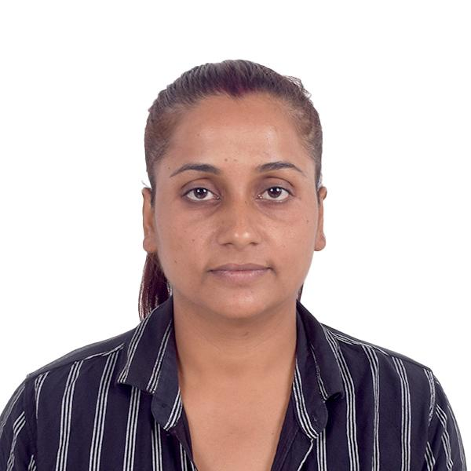

**Objective :**

To contribute my sincere efforts for the growth and prosperity of an organization through which I can seek a career opportunity, where my dedication and hard work will gain me a position of substantial responsibility with potentials for growth.

**Academic Qualification :**

* Higher Secondary Diploma certificate from Panchayat Higher Secondary School, Pathari, Nepal.

**Additional Qualification / Training :**

Basic computer knowledge.

**Work Experience** :

* Worked as a Sales representative in Jalapa Devi Supermarket Pathari, Nepal From January 2018 to July 2022.
* Worked as sales staff / Cashier at Bhat Bhateni Supermarket, Ithari From September 2022 to September 2023.
* **Responsibilities :**
* Providing product information to the client.
* Managing all accounting transactions.
* Receiving customer requirement and supply on time.
* Preparing daily and monthly reports.
* Billing sold items and collect the payment from customer
* Providing customer care service to the customer.
* Promoting product and selling to the customer.
* Reporting day to day activity to the superior.

**Personal Skills:**

* Excellent communication
* Good in time management and teamwork
* Ability to work under pressure with deadlines
* Customer relations & have well public relationship knowledge • All other qualifications the position justifies.

**Personal Details :**

# Name : Deepa Dahal

|  |  |
| --- | --- |
| Date of birth | : 28/04/1992 |
| Marital Status | : Married |
| Gender | : Female |
| Nationality | : Nepali |
| Passport No | : 11543592 |
| Visa Status | : Visit visa valid for 2 Months |
| Languages | : English, Hindi, Nepali |

**Declaration:**

I hereby declare that the above mentioned information is correct up to my knowledge and I bear the responsibility for the correctness of the above mentioned particulars.

***DEEPA DAHAL***