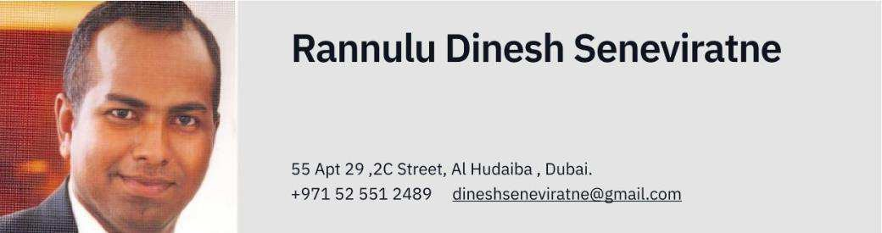
STRATEGY PROFILE
I have acquired diverse local and international experience across various roles, including sales, warehouse and store management, inventory control, administration, organizational skills, and planogram design and setup identification. My background includes significant contributions to major retail giants such as Landmark Group in KSA and the petroleum retailing industry with ENOC in the UAE.
EXPERIENCE PROFILE
Operational Director (Entrepreneur) Advent Travels & Rent a Car - 2010 – 2024
- Operational Director at Advent Travels & Rent a Car, overseeing end-to-end operations in travel and tourism throughout Sri Lanka.
- Managed the total vehicle fleet, including operations and maintenance.
- Possess a strong understanding of vehicle maintenance and repair operations.
- Developed and implemented operational strategies to improve efficiency and customer satisfaction.
- Coordinated with travel and tourism partners to ensure seamless service delivery.
- Supervised staff, ensuring optimal performance and adherence to company policies.
- Analyzed operational data to make informed decisions and drive business growth.
- Ensured compliance with all relevant regulations and standards in the travel and tourism industry.
Emirates & National Oil & Petroleum Company (ENOC) UAE - 2007 –2010
- Managed petroleum retail and convenience store operations, overseeing FMCG products.
- Ordered supplies, and managed stock receipt and inventory.
- Oversaw staff administration, including scheduling and overtime.
- Excelled in preparing management reports.
- Handled customer issues effectively.
- Certified in EHS safety for decanting operations.
- Practical experience with Microsoft Brio Intelligence, MS Office, and C-Pay systems.
Inventory Control Executive at Abans Ltd LG - 2006 – 2007
- Served as an Inventory Control Executive overseeing LG-branded electronic and electric appliances across 170 branches.
- Generated MIS reports, audit trail reports, month-end reports, and stock movement reports.
- Managed branch operations nationwide.
- Conducted regular audits to ensure inventory accuracy and compliance.
- Implemented inventory control procedures to optimize stock levels and reduce discrepancies.
- Coordinated with branch managers to streamline operations and improve efficiency.
- Developed and maintained inventory databases for accurate tracking and reporting.
- Analyzed sales data to forecast inventory needs and adjust stock levels accordingly.

Landmark Group Dorrat Al Wadi Limited. KSA - 2004 – 2006
- Worked as a Senior Salesman, Store Supervisor, Assistant Manager, and Inventory Controller in warehouse operations for furniture and household items.
- Handled stock takes and generated MIS reports.
- Created stock aging reports for management.
- Prepared seasonal sales presentations for the management.
- Managed inventory control to ensure accurate stock levels.
- Supervised store operations and staff to maintain high performance.
- Coordinated with various departments to streamline operations and improve efficiency
Customer service assistant & Supervisor at Richard Pieris Distributors (PVT) LTD (ARPICO) - 2000 – 2004
Experience working as a Customer Service Assistant and Supervisor in the FMCG sector, where I managed stock takes, handled administration tasks, and was responsible for cash handling.
Lab Technician Ordering Stocks Management at Jonathan’s (Pvt) Limited - 1998 – 1999
Worked as Lab Technician ordering stocks management and front-end sales.
Sales Executive at Uniferbes Associates - 1996 – 1998
EDUCATION
Qualification | Institute/School | Year
GCE O/L | Royal College Panadura | 1993
GCE A/L | Royal College Panadura | 1996
Diploma in English | Aquinas College of Higher Studies | 1999
COMMUNICATION SKILLS
I possess exceptional written and verbal communication skills in English, along with confident and professional speaking abilities. I have experience in public speaking, presentations, and negotiation.
LEADERSHIP SKILLS
In Administration and management, Hands on experience in ERP management software.
PERSONAL PROFILE
Name in full : Rannulu Dinesh Seneviratne
Contact Number : +971 52 551 2489
Date of Birth :28th June 1977
Nationality :Sri Lankan
Driving License : UAE Valid (International License)
I do hereby certify that the above-mentioned particulars are true & accurate to the best of my knowledge.

