MD EHTESHAM

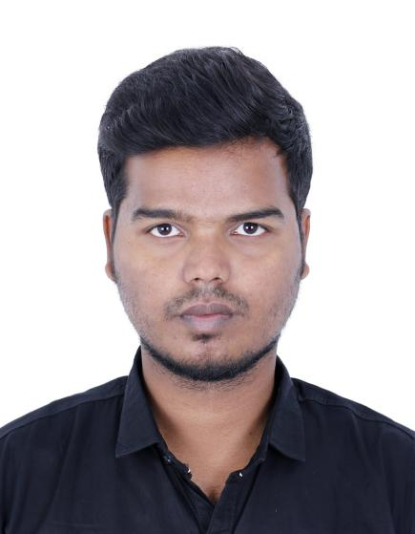

*MBA (Human Resources)*

**SUMMARY**

"Seeking a challenging and innovative position in a firm that will maximize the opportunities for me to implement my skill set and knowledge as well as use my capabilities in the best way possible so that I can enrich my skills and aid the development of the firm I work with."

**+971567807411**

[ehti.mohd18](mailto:afnanraza62@gmail.com)**[@gmail.com](mailto:afnanraza62@gmail.com)**

**Khalid Bin Al Waleed Road – Al-Raffa Street – Bur Dubai – Dubai**

**PERSONAL DETAILS**

**Father Name :- MD AKBER**

**Date Of Birth :-** 12-march-1999 **Religion :-** Islam **Nationality :-** Indian

**Address :-Hyderabad**.

**VISA Type :-** Visit VISA

**VISA Expiry** :- 06-03-2024

**Passport No. :- Y**6749426

# LANGUAGES

* **Hindi**
* **English**
* **Urdu**

***EXPERIENCE***

## Hiring Executive

#### INDIA [Oct 2021 - Dec 2023]

* Provided support to employees with various HR-related issues and liaised with heads of department to find resolutions.
* Managed the hiring processes within the company, dealing with matters including writing adverts, reviewing CVs, interviewing and selecting candidates.
* Set up compensation and benefits structures according to market conditions and budget demands.
* Implemented team building activities to enhance positive working environments.
* Developed HR strategies and initiatives, aligning with overall business strategy.

## **Vice Principal**

INDIA [Oct 2021 - Dec 2023]

* Verified achievement of educational programme objectives and standards through continual performance monitoring and evaluation.
* Scrutinized the processes and outcomes of initiatives to maintain compliance with local and national funding sources.
* Visited classrooms and evaluated teacher instructional techniques and student responses.
* Held meetings with teachers to review current classroom policies and determine strategies for improvement.

# SKILL HIGHLIGHTS

* **Strong communication and interpersonal abilities**
* **Ability to work independently or as part of a team**
* **Time management and organization skills**
* **Leadership and management experience**
* **Problem- solving and critical thinking skills**
* **Attention to detail and accuracy**
* **Ability to think long- teím and develop a plan of action to achieve specific goals**
* **Customer service skills**

# TECHNICAL SKILLS

* **MS Excel**
* **MS Word**
* **MS Powerpoint**
* **Tally ERP 9**
* **Tally 9**
* **Tally Prime**

**STRENGTH**

* Active listening
* Attention
* Written communication
* Presentation

### **Accountant**

#### IIIS, India

[June 2019 - Aug 2022]

* Posted accounts receivable payments made by cash, cheque or credit card payments.
* Coordinated month-end closing processes to ensure completion ahead of aggressive deadlines.
* Used [Tally ERP & Tally prime] accounting software to perform bookkeeping, invoicing and bank reconciliations.
* Completed updates to general ledger by adding latest entries, submitting them accurately and within time frames.
* Communicated with senior management on status of capital appropriations budget.

***EDUCATION***

## Master of Business Administration (HR)

*MRM INSTITUTE OF MANAGEMENT*

*(Aug 2023)*

## Bachelor of Education

*Sri Chakra College Of Education (Jun 2021)*

## Bachelor of commerce (Computers)

*Mumtaz Degree & P.G College (Jun 2019)*

## Intermediate MEC

*Visionary junior college (Apr 2016)*

## SSc

*Phoenix international school (mar 2014)*

* ***HOBBIES & INTREST***
* *Playing Cricket*
* *Reading Stories*
* *DECLARATION*

I hereby declare that the above information is true to the best of knowledge and belief. I also promise to work with the best of my capabilities and abide by norms of the organization

*(MD EHTESHAM)*