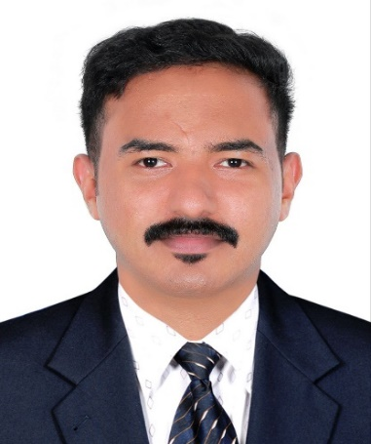 |  | EMMANUEL ABIN CHACKOCHAN  Career objective  Logistics Coordinator with 4 years' experience in supply chain management, transportation, Finished goods and inventory control, and customer relations. Proven expertise in streamlining operations and reducing costs while maintaining customer satisfaction.
Contact    +971 527428156    emmanuelabinakasalayil@gmail.com    Dubai (UAE)  Languages  English  Hindi  Tamil  Malayalam  Additional INFORMATION  Date of Birth : 18 Oct 1998  Age : 26Yrs  Sex : Male  Nationality : Indian  Marital Status : Single  Passport No. : T6874398  Date of Issue : 12 July 2019  Date of Expiry : 11 July 2029  Visa Status : Resident Visa |  | WORK EXPERIENCE  EMIRATES FLOAT GLASS COATER, DUBAI - AUG 2022 > PRESENT.  In charge of dispatch and logistics.  - Managed the logistics of a wide variety of shipments, including both domestic and international shipments.  - Prepare accurate shipping documents for custom clearances for import, export, and re-export.  - Utilized inventory management software to maintain accurate records of inventory levels and shipments.  - Monitored warehouse operations to ensure quality control and efficient workflow.  - Maintained relationships with key customers to provide the highest level of customer service.  - Operating EOT Crane, Forklift and robotic stacking machines  BHARATH PETROLIUM CORPORATION LIMITED,KOCHI–OCT 2020 > MARCH 2022  Logistics coordinator.  - Coordinate and monitor supply chain operations  - Prepare documents and reports  - Identify and fix shipping errors  - Supervise, coach and train warehouse workforce  AMPHENOL FCI OEN CONNECTORS LTD,KOCHI-SEP 2018 > SEP 2020  Machine operator.  - Operating of vertical and horizontal molding machines.  EDUCATION  - Completed Diploma in Mechanical ITI Fitter from government ITI Ettumanoor, Kerala, India. (2016-2018).  - Higher Secondary education in piravom, Kerala, India. (2014-2016).  TECHNICAL EXPERTISE  - Oracle ERP  - Microsoft Office  - Microsoft excel

